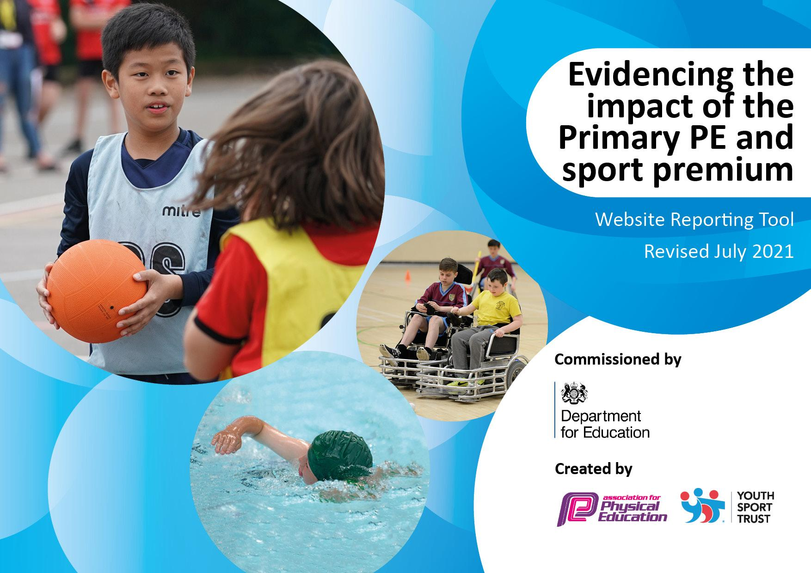
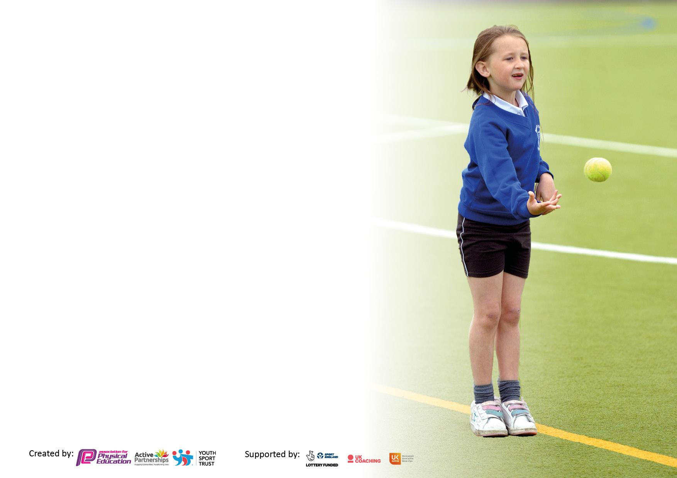

It is important that your grant is used effectively and based on school need. The Education Inspection Framework makes clear there will be a focus on ‘whether leaders and those responsible for governors all understand their respective roles and perform these in a way that enhances the effectiveness of the school’.

Under the Quality of Education Ofsted inspectors consider:
Intent - Curriculum design, coverage and appropriateness
Implementation - Curriculum delivery, Teaching (pedagogy) and Assessment
Impact - Attainment and progress

To assist schools with common transferable language this template has been developed to utilise the same three headings which should make your plans easily transferable between working documents.

Schools must use the funding to make additional and sustainable improvements to the quality of Physical Education, School Sport and Physical Activity (PESSPA) they offer. This means that you should use the Primary PE and sport premium to:

- Develop or add to the PESSPA activities that your school already offer
- Build capacity and capability within the school to ensure that improvements made now will benefit pupils joining the school in future years
- The Primary PE and sport premium should not be used to fund capital spend projects; the school’s budget should fund these.

Pleasevisitgov.ukfortherevisedDfEguidanceincludingthe5keyindicatorsacrosswhichschoolsshoulddemonstrate animprovement.Thisdocumentwillhelpyoutoreviewyourprovisionandtoreportyourspend.DfEencouragesschools to use this template as an effective way of meeting the reporting requirements of the Primary PE and sport premium.

We recommend you start by reflecting on the impact of current provision and reviewing the previous spend.

Schools are required to publish details of how they spend this funding, including any under-spend from 2019/2020, as well as on the impact it has on pupils’ PE and sport participation and attainment. All funding must be spent by 31st July 2022.

We recommend regularly updating the table and publishing it on your website throughout the year. This evidences your ongoing self-evaluation of how you are using the funding to secure maximum, sustainable impact. Final copy must be posted on your website by the end of the academic year and no later than the 31st July 2021. To see an example of how to complete the table please click HERE.


Details with regard to funding
Please complete the table below.

Total amount carried over from 2019/20 | £0.00
Total amount allocated for 2020/21 | £18,950
How much (if any) do you intend to carry over from this total fund into 2021/22? | £0.00
Total amount allocated for 2021/22 | £19,580
Total amount of funding for 2021/22. To be spent and reported on by 31st July 2022. | £19,580

Swimming Data
Please report on your Swimming Data below.

Meeting national curriculum requirements for swimming and water safety.

N.B. Complete this section to your best ability. For example you might have practised safe self-rescue techniques on dry land which you can then transfer to the pool when school swimming restarts.
Due to exceptional circumstances priority should be given to ensuring that pupils can perform safe self rescue even if they do not fully meet the first two requirements of the NC programme of study
What percentage of your current Year 6 cohort swim competently, confidently and proficiently over a distance of at least 25 metres?  N.B. Even though your pupils may swim in another year please report on their attainment on leaving primary school at the end of the summer term 2020.  Please see note above | 53%
What percentage of your current Year 6 cohort use a range of strokes effectively [for example, front crawl, backstroke and breaststroke]?  Please see note above | 53%
What percentage of your current Year 6 cohort perform safe self-rescue in different water-based situations? | 48%
Schools can choose to use the Primary PE and sport premium to provide additional provision for swimming but this must be for activity over and above the national curriculum requirements. Have you used it in this way? | No

Action Plan and Budget Tracking
Capture your intended annual spend against the 5 key indicators. Clarify the success criteria and evidence of impact that you intend to measure to evaluate for pupils today and for the future.

Academic Year: 2021/22 | Total fund allocated: £19,580 | Date Updated: 18.07.2022
Key indicator 1: The engagement of all pupils in regular physical activity – Chief Medical Officers guidelines recommend that primary school pupils undertake at least 30 minutes of physical activity a day in school |  |  |  | Percentage of total allocation:
 |  |  |  | 39%
Intent | Implementation |  | Impact
Your school focus should be clear what you want the pupils to know and be able to do and about  what they need to learn and to  consolidate through practice: | Make sure your actions to achieve are linked to your intentions: | Funding allocated: | Evidence of impact: what do pupils now know and what can they now do? What has changed?: | Sustainability and suggested next steps:
Outside agencies to support the teaching and learning of a variety of sports. | Professional dance teacher coming in once a week to teach all year groups with KS2 on a rota basis.  Football coach from King’s Lynn town football club coming in once a week to teach KS1 and KS2 classes on a rota basis. | £5,550  £2110,00 | The children are taught dance skills by a specialised teacher. There are children that have been inspired by their lessons and have taken up dance/theatre lessons outside of school. There are also children that have had the confidence to audition for the year 5 and 6 shows when they wouldn’t have before.  The football coach has given out free tickets to the King’s Lynn local football matches and children that have not ever experienced going to such events have been able to attend with their families. Children have also been inspired to join football clubs outside of school.  Children are taught football and multi-skills by a specialist. | To continue to have the specialised dance teacher in to continue to enhance children’s skills, upskill teaching staff and inspire children to take up dance outside of school.  To continue to have a specialised football coach to continue to upskill staff, inspire children to take up football in a club outside of school.
Key indicator 2: The profile of PESSPA being raised across the school as a tool for whole school improvement |  |  |  | Percentage of total allocation:
 |  |  |  | 14%
Intent | Implementation |  | Impact
Your school focus should be clear what you want the pupils to know and be able to do and about  what they need to learn and to  consolidate through practice: | Make sure your actions to achieve are linked to your intentions: | Funding allocated: | Evidence of impact: what do pupils now know and what can they now do? What has changed?: | Sustainability and suggested next steps:
To maintain the high profile of P.E across the school through competing in competition locally. | To work with West Norfolk School Sports Partnership. | £2,835.00 | Children are provided with an outstanding range of extra-curricular activities in the local community. Children have the opportunity to take part in a range of competitions and festivals.  Some of the children who have attended the development opportunities have gone on to join clubs outside of school, such as the local pelicans hockey club and the tennis club at Lynnsport.  Sports leaders have been selected and received training, which has led them to help at sports festivals for the year 2 children and helped out in events such as sports day.  St Martha’s were very successful in the competitions run by West Norfolk sports partnership. These successes include;  6 children got through in the top ten qualifiers in the cross country competition with 2 securing first place.  Year 6 won the tag rugby tournament.  The year 4’s came second in West Norfolk in the tennis competition and secured 4th place in the Norfolk county finals.  The year 6 girls secured 3rd place in West Norfolk in cricket.  The year 6 boys came 2nd in West Norfolk and 2nd in the Norfolk county finals.  Quad kids competition - St Martha’s year 6 team came first place and a girl and boy from St Martha’s were overall top scorers. | Due to the number of successes in West Norfolk and County final competitions, we will continue our partnership with WNSSP.  The development opportunities children within the school have received are invaluable. We have had many children who have enjoyed the experience/sport so much that they have joined the local clubs outside of school.  The sports leaders will continue to help at the school sports day and the sports festivals with year 2 children and in addition, run an in-house festival for those year 2 children that do not attend a festival.

Key indicator 3: Increased confidence, knowledge and skills of all staff in teaching PE and sport |  |  |  | Percentage of total allocation:
 |  |  |  | 7%
Intent | Implementation |  | Impact
Your school focus should be clear | Make sure your actions to | Funding | Evidence of impact: what do | Sustainability and suggested
what you want the pupils to know | achieve are linked to your | allocated: | pupils now know and what | next steps:
and be able to do and about | intentions: |  | can they now do? What has
what they need to learn and to |  |  | changed?:
consolidate through practice:
Buying into the Get Set 4 P.E scheme to upskill all teaching staff and increase confidence, knowledge and skills. | The Get Set 4 P.E scheme includes videos to support teachers. | £1375.00 | Teachers now have a P.E scheme that is easy to follow and has lessons plans available that they can print off each lesson. There are also videos for most lessons that can be shown to the children prior to the lesson in the classroom. The feedback from all teachers is all positive and the staff survey results show that they are more secure in their skills and knowledge. | Due to the success of Get.set4 the positive feedback from staff we have received, we will continue to use and pay for this scheme. The teacher’s confidence in teaching P.E has increased and the feedback we have received from pupils has been equally positive.
Key indicator 4: Broader experience of a range of sports and activities offered to all pupils |  |  |  | Percentage of total allocation:
 |  |  |  | 45%
Intent | Implementation |  | Impact
Your school focus should be clear | Make sure your actions to | Funding | Evidence of impact: what do | Sustainability and suggested
what you want the pupils to know | achieve are linked to your | allocated: | pupils now know and what | next steps:
and be able to do and about | intentions: |  | can they now do? What has
what they need to learn and to |  |  | changed?:
consolidate through practice:
Additional achievements:  Year 5 to have sailing lessons provided by a professional sailing club.  A wide range of after school clubs run by staff members with specialist skills.  Archery equipment purchased to ensure archery after school club can run. | Children to develop skills in a sport they may never have tried before.  Pupils provided with a broader experience in a sport they haven’t tried before.  Archery equipment purchased. | £2520.00  £7131.00  £159.00 | Children experience and develop new skills in a new sport.  Children develop skills in a wide range of sports.  Archery after school club can be offered to more pupils with the correct amount of equipment. | This opportunity has been successful, however it will need to be reviewed next year.  To continue to offer children a broad range of sports opportunities.  Mrs Reeve is happy to continue running this club and has vast experience in the sport.

Key indicator 5: Increased participation in competitive sport |  |  |  | Percentage of total allocation:
 |  |  |  | %
Intent | Implementation |  | Impact
Your school focus should be clear | Make sure your actions to | Funding | Evidence of impact: what do | Sustainability and suggested
what you want the pupils to know | achieve are linked to your | allocated: | pupils now know and what | next steps:
and be able to do and about | intentions: |  | can they now do? What has
what they need to learn and to |  |  | changed?:
consolidate through practice:
Maintain the high profile of P.E | Working with West Norfolk school Sports Partnership has given us a plethora of opportunities to take part in competitive sports, in which we have had great successes. | See Key Indicator 1 for figures. | Successes in a range of competitive sports including reaching County level. | To continue with the WNSSP due to the successes we have had as a school in competitions, continuing to inspire children that do not get the chance to participate in sports outside of school in development opportunities.

Signed off by
Head Teacher:
Date:
Subject Leader:
Date:
Governor:
Date:

