

Field Lane, King’s Lynn, Norfolk, PE30 4AY

Behaviour Policy

2025 - 2026

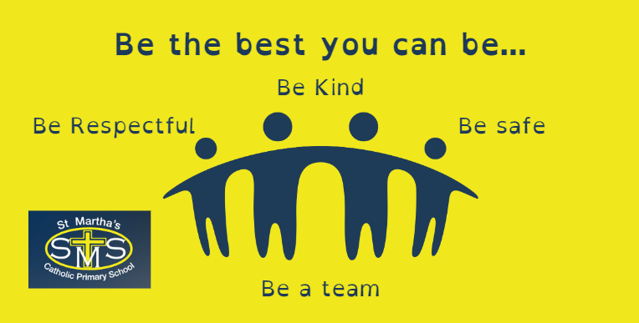

Our vision is to create a community based on Catholic faith and values where every child is empowered to be the best he or she can be, nurtured by outstanding teachers, staff and governors.

Review date: October 2026
Contents
Aims …………………………………………………………………………………………………………………………….. 2-3
Legislation, Statutory Requirements and Statutory Guidance………………………………………. 4
Related Policies …………………………………………………………………………………………………………….4
Key Terms and Principles ……………………………………………………………………………………………... 5
Expectations of Adults ………………………………………………………………………………………………….. 6
Creating and Environment for Positive Behaviour …………………………………………………………. 7
Relationships ………………………………………………………………………………………………………………8-10
Routines ……………………………………………………………………………………………………………………….. 10
Responses: Recognition of Positive Behaviour …………………………………………………………...... 11
Responses: Behaviours that Challenge ………………………………………………………………………….. 12
Responses: the Intervention Ladder ……………………………………….……………………………………. 13-14
Responses: Zero-Tolerance Behaviour …………………………………………………………………………… 15
Behaviour as an Additional Need: Behaviour Plans ……………………………………………………….. 16
Behaviour as an Additional Need: SEND ………………………………………………………………………… 16
Roles and Responsibilities ……………………………………………………………………………………………... 17-18
Appendix A: Restorative Practice Board ……………………………………………………………………….. 18
Appendix B: Scripted Responses …………………………………………………………………………………….19
Appendix C: Physical Interventions………………………………………………………………………………….20
Appendix D: Further Reading…………………………………………………………………………………………. 26




Aims
The purpose of this policy is to guide teachers, children and parents on our restorative and relationship focused approach to managing behaviour. This will allow the children at St Martha’s to enjoy a calm, nurturing and caring environment which supports them both emotionally and educationally to give them the best possible chance of success.
Our school is committed to creating an environment where exemplary behaviour is at the heart of productive learning. Everyone is expected to maintain the highest standards of personal conduct, to accept responsibility for their behaviour and encourage others to do the same. Our behaviour policy guides staff to teach self-discipline and it echoes our core values with a heavy emphasis on respectful behaviour, a partnership approach to managing behaviour that challenges and dynamic interventions that support staff and learners. Consistency, and clear, calm adult behaviour underpins this.
It is a primary aim of our school that every member of the school community feels valued and respected, and that each person is treated fairly and well.
At St Martha’s we have 4 core values which guide us in our relationships. These values are rooted in the gospel values. They are displayed in all classrooms and staff make constant reference to them and our Mission Statement (“Be the best you can be”) in daily interactions with children both to reinforce positive behaviour and in response to behaviours that challenge.
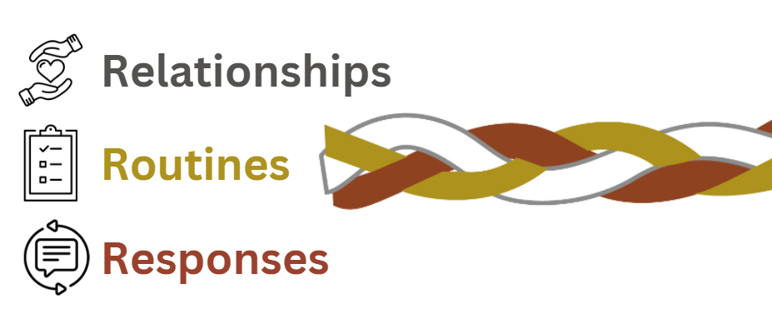
We aim to create a predictable and secure environment for colleagues and children. Backed up by research, we prioritise the importance of planning for clear routines and responses, and the building of relationships (Bennett, 2017).

 | Our Aims | Our understanding | Our actions
Relationships   | To build respectful, trusting and caring relationships in our school. | Children respond to adults when they know they are cared for and respected. They will be their best (as learners, friends and members of the school community) if they feel part of a community rooted in respect, trust and care. | We, as the adults, always model calm, controlled and caring behaviour. We should model positive relationships in our day-to-day contact with everyone. As stated in our Code of Conduct Policy, adults should not shout at children unless it is a situation of safety and someone is at risk.
Routines   | To ensure that everyone feels safe at school through the consistent use of clear, concise routines and a culture of high expectations. | Consistent routines and high expectations provide a predictable, secure and safe learning environment. Children are more likely to be calm, focused and regulated if they know what is expected of them. | We have high expectations for the behaviour of all children.  Routines are taught in the classroom and at a whole school level.  Routines are explicitly taught and maintained using visuals (dual coding, Widgit symbols, Makaton) where appropriate to ensure all children understand.
Responses   | To ensure responses to positive behaviour and behaviour that challenges are consistent and understood by all staff. | Children have a strong sense of what is fair and will resent and feel frustrated by inconsistencies. | Our attention as adults is focused on recognising children who are meeting our high expectations.  Our School Values are referred to in every discussion about conduct.  We ensure all feedback is constructive and educational.
Legislation, Statutory Requirements and Statutory Guidance
This policy is based on legislation and advice from the Department for Education (DfE) on:
- Behaviour in schools: advice for headteachers and school staff 2022
- The Equality Act 2010
- Keeping Children Safe in Education
- Suspension and permanent exclusion from maintained schools, academies and pupil referral units in England, including pupil movement 2023
- Use of reasonable force and other restrictive interventions in schools Guidance for schools in England February 2025
- Supporting children with medical conditions at school
- Special Educational Needs and Disability (SEND) Code of Practice 2014

Related Policies
This policy must be read in conjunction with the following whole school policies:
- Safe Touch Policy
- Safeguarding Policy
- Anti-Bullying Policy

Key Terms and Principles

Behaviours that challenge: withdrawal from learning, being out-of-seat, calling out in class, refusing to follow instructions, answering back.
Behaviours that harm: intimidating behaviour (threatening throw objects, invading personal space), persistently challenging staff in an attempt to undermine, verbally or physically aggressive behaviour to peers or staff, leaving the classroom, damage to school property.
Interventions: planned responses to support and promote positive behaviour such as restorative conversations, the use of sensory tools or breaks etc.
Logical Consequences: Logical consequences are designed to provide students with an opportunity to learn from their mistakes, not lower their self-esteem.
Emotional regulation: Emotional regulation is the ability to manage our emotions.
Self-regulation: the ability to understand and manage your behaviour and your reactions to feelings and things happening around you.
Co-regulation: the ability to regulate emotions and behaviours, manage stress (internal or external), and return to a calm state, with the support and direction of a connecting person.
Dysregulated: dysregulation, or emotional dysregulation, is an inability to control or regulate one's emotional responses.
Restorative Practice: restorative practice is a term used to describe behaviours, interactions and approaches which help to build and maintain positive, healthy relationships, resolve difficulties and repair harm where there has been conflict.
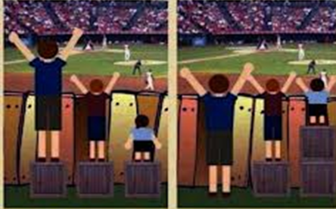
Equity versus Equality: Equality of opportunity is not the same as equality of provision. Children are individuals. Our aim is always to allow equality of opportunity and to achieve this, we understand that provision will vary. Being ‘fair’ is not about everyone getting the same (equality) but about everyone getting what they need (equity).

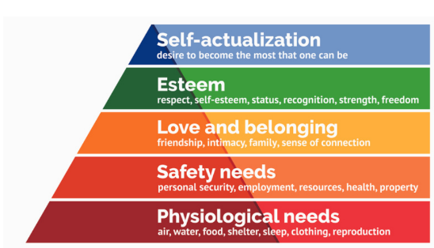
Behaviour is communication: The Special Educational Needs Code of Practice 2015 refers to Social, Emotional and Mental Health difficulties (SEMH), promoting a shift toward viewing behaviour as a communication of an emotional need whether conscious or unconscious, and responding accordingly. Taking a non-judgemental, curious and empathetic attitude towards behaviour will encourage all adults in school to respond in a way that focuses on the feelings and emotions that drive certain behaviours, rather than the behaviour itself. Maslow’s Hierarchy of Needs: this theory is how humans are motivated to fulfill our needs. Ultimately, needs lower down in the hierarchy must be satisfied before individuals can tend to needs higher up. When we talk about the needs behind behaviour, we can use this as a guide.
Expectations of Adults
We expect every adult to:
- Refer often to our values of: ‘Be Respectful, Be Kind, Be Safe, Be a Team’, and demonstrate these themselves.
- Model positive behaviours and consciously strive to build positive relationships with children and each other.
- Be proactive in behaviour management - plan lessons that engage, challenge and meet the needs of all children in line with the Teaching and Learning Policy.
- Be prepared for the day so that resources are ready in advance and staff can be deployed to support behaviour during learning time and transitions.
- Carefully structure the school day so that children are provided with sensory breaks (Daily Mile, GoNoodle, class games such as ‘Simon Says’, movement breaks on YouTube) and are not expected to sit and listen for extended periods (this will vary according age and the needs of the class).
- Catch and praise children for positive behaviour, but never ignore or walk past children who are not meeting our high expectations.
- Use a range of non-verbal cues to encourage or re-focus expected behaviour such as:
- Dual coding/Widgit symbols
- Voice-o-meters (noise level displays)
- Makaton signs/non-verbal signals which children can use to communicate needs (“I need the toilet”, “I need help”, “Can I visist the Calm Corner?”)
- Now/Next Boards
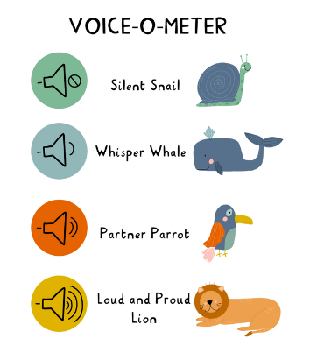
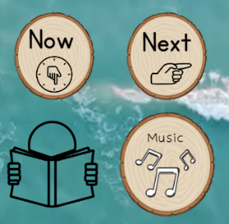

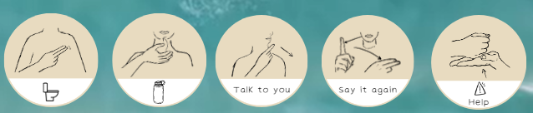
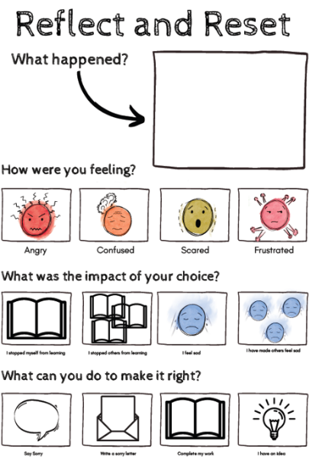

- React calmly to negative behaviour, using appropriate strategies (such as de-escalation and restorative scripts - Appendix A and B) to de-escalate and refocus attention.
- Follow up poor behaviour every time, in line with this policy, retaining ownership and engaging in reflective dialogue with children.
- Seek support and guidance from other members of staff (former teachers, LSAs, the SENCO, SLT) when children are presenting with challenging behaviour.

Creating an Environment for Positive Behaviour

We know that the physical environment plays a vital part in setting high expectations and ensuring children from all social, cultural and religious backgrounds feel valued. This includes:

- Being good custodians, respectful of others’ belongings and ensuring that the school/classrooms are kept tidy and welcoming.
- Children being given some choice in how their classroom is organised (children could be responsible for keeping the class reading area tidy, monitoring cloakrooms and sharpening pencils etc.).
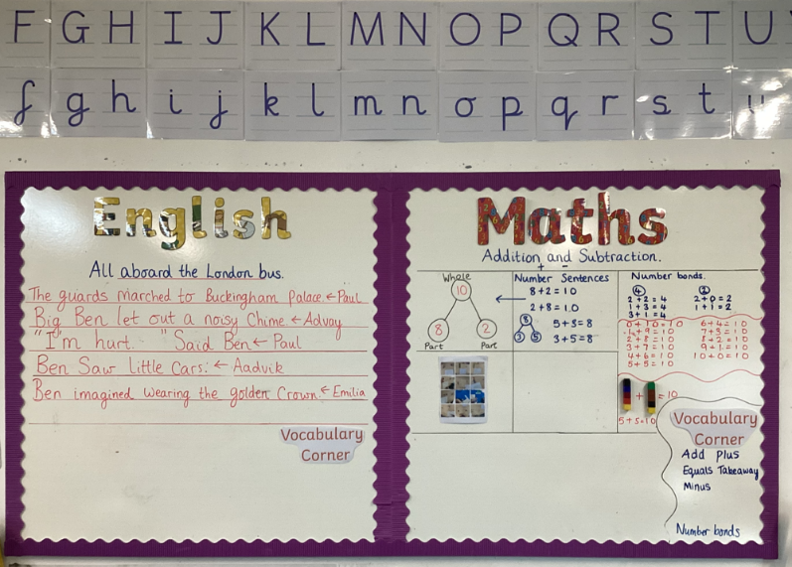
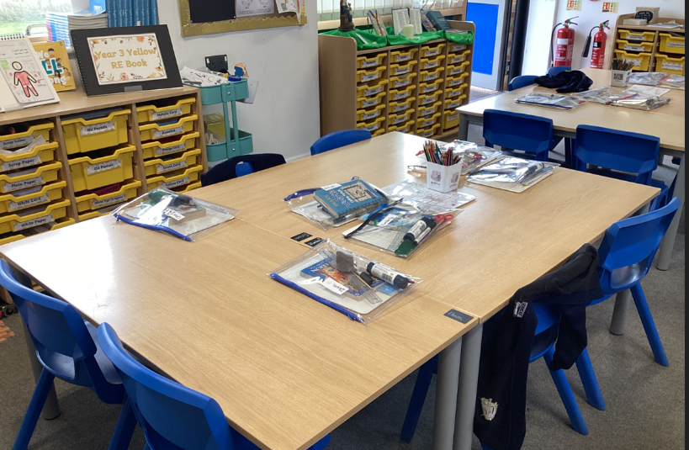
Displays are clear, easy to read and support children to access the learning.
Children have their own space with the resources they need. Everything is tidy, organised and accessible. There is space for children to move easily around the classroom.

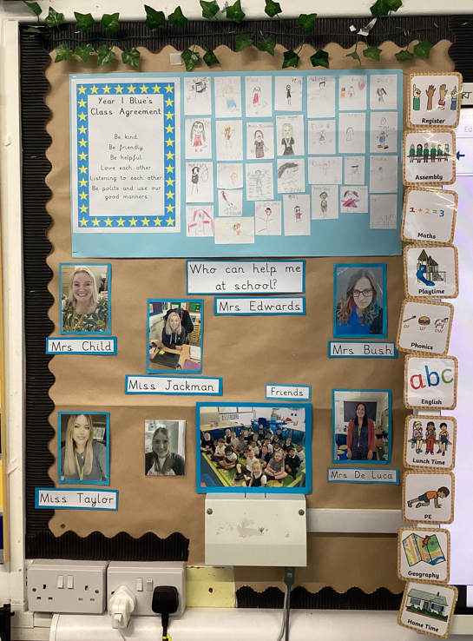
- Being mindful of sensory overload in the classroom, particularly displays near the interactive whiteboard.
- Ensuring good quality displays of children’s work across all ability ranges and resources that reflect the varied ethnicities and abilities across the school and act as a support for learning.
- Ensuring that resources are labelled and organised in a way that is practical and accessible to to children.
- Careful consideration is given to where individuals sit and who they sit next to
- Furniture being arranged to allow for maximum learning to take place and enough space being made available for children to move around the classroom comfortably and access resources
- Teaching resources of good quality, adequate in quantity and text is large enough for children to read from a distance
- Adults establishing clear, consistent routines for e.g. resource management, how books are given out etc.
Visual timetables reduce worry and certainty about the day and make children feel more in control. Fonts are easy to read. Information displayed is informative.
- Visual timetables displayed in classrooms

Relationships
“Every pupil should have a supportive relationship with a member of school staff.” (EEF, Improving Behaviour in Schools, 2019)

The way that adults speak to children, and about children, and the way that adults encourage children to speak to each other, directly impacts on the self-esteem, confidence and motivation that children have, which in turn impacts on the children’ behaviour. All adults need to act as good role models for children including the way that they speak, dress, behave, etc. in every possible situation, e.g. class, playground, assembly hall. All adults need to ensure that their children understand and celebrate difference.
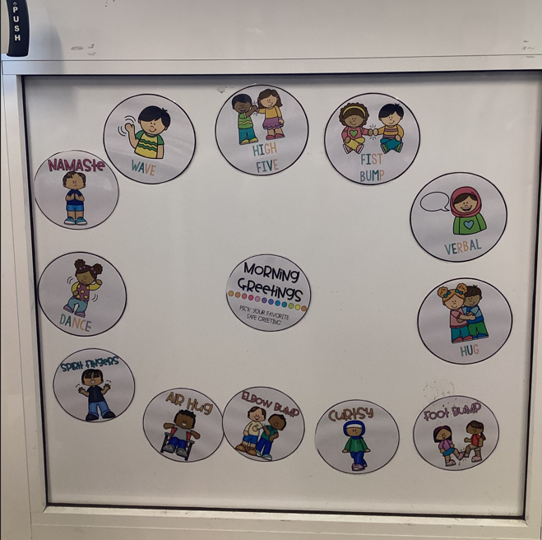
Ways in which we build positive relationships at St Martha’s:

- Greeting every child by name at the start of the school day.
- Establish the class as a team or family at the start of the year (through team building activities, creating class flags, mottos and class agreements, and referring to the class as a team e.g. Team Year 4 Blue).
- Class Sensory breaks - games and activities to build a sense of community in the classroom.
- Having high expectations for all our children’s behaviour.
- Focusing on the positive.
Routine for greeting children in the morning.
- Being consistent and fair.
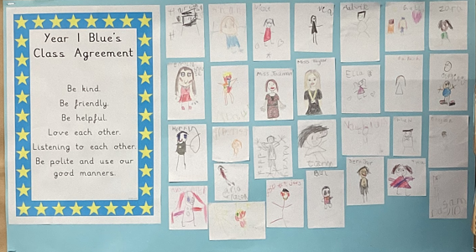
- Focusing on the behaviour and not the person (saying ‘That is rude’ rather than ‘You are rude’).
- Not always insisting on eye contact (some children find this very difficult, especially those with Autism or communication difficulties).
- Avoiding confrontation if possible by asking the child questions or mirroring what they are saying to show you are listening.
- Use your voice carefully and effectively; for example tone and volume.
Class Agreement signed by all children.
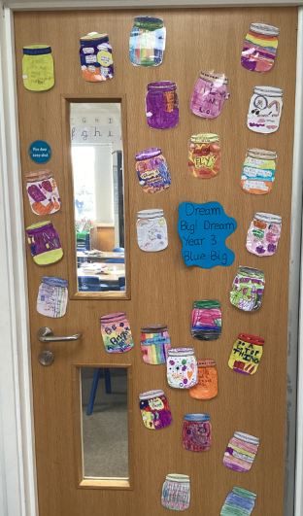
- Giving clear choices.
- Providing calm down time.
- Allowing for ‘take-up-time’ after you have issues instructions by walking away and giving the child a few minutes to process, regulate and make their choice.
- Listening to what children say and not jumping to conclusions.
- Remembering ‘New day – new start!’ and communicating this to the child in a clear manner.
- Reporting positive behaviour to parents.
- For children who find relationships more challenging and who consistently present with unsettled and/or distressed behaviour, we ensure all staff who work with that child are given key information on how to respond to that child through Positive Behaviour Plans.
Whole class displays create a sense of belonging.

- The use of positive phrasing:

Negative phrasing | Positive phrasing
Stop being silly! | Sit quietly, thank you!
Don’t throw the pen! | Put the pen on the table.
Stop running! | Walking inside!
Calm down. | Would you like some time in the Calm Corner or are you ready to learn now?
Don’t shout out the answer! | Hands up please!

Norfolk Steps

We follow the Norfolk Steps Step On approach. It is based on therapeutic approaches and its philosophy and method involves the use of de-escalation, consistency, good communication and planning in order to reduce the incidences of challenging behaviour.

Emotional Literacy

In order to build meaningful and healthy relationships with those around them, children need to be given opportunities to develop their Emotional Literacy. Our PSHE and RSE programme has been designed to ensure we are:

- Teaching children about their emotions progressively each year.
- Teaching about The Zones of Regulation and regulation techniques.
- Developing a growth mindset approach to learning in all classrooms.
- Explicitly teaching how to become good members of the community (this is also delivered through our RE curriculum).
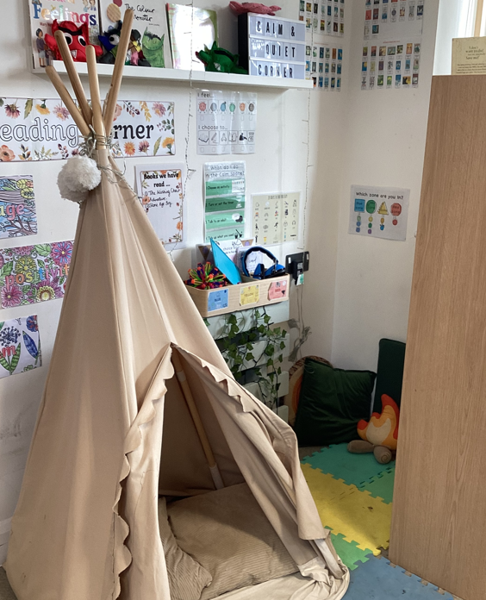
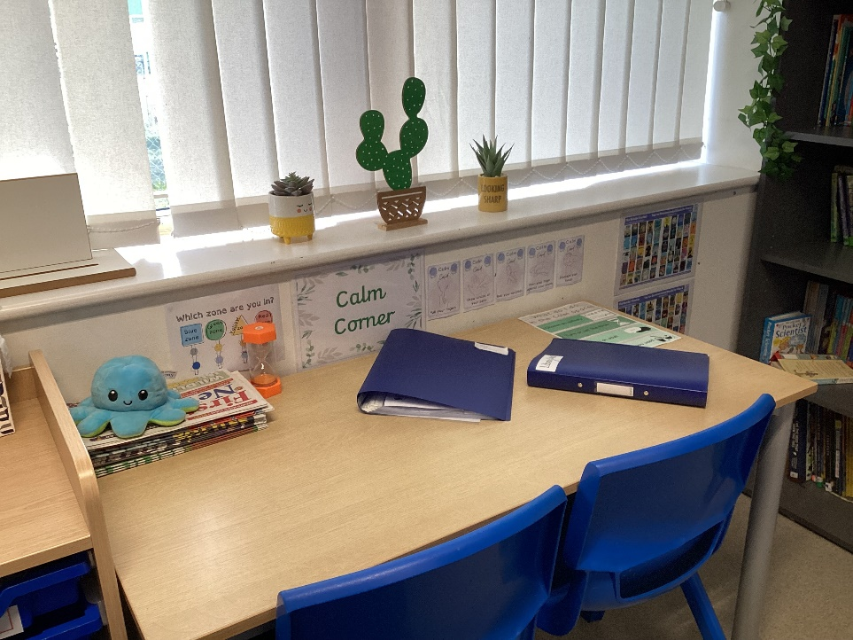
All classrooms have a designated calm space where the Zones of Regulation are displayed and various activities are provided to support with self-regulation (sensory tools, colouring, breathings cards etc.).

School assemblies are also used to explicitly teach values and further enhance and sustain a sense of community and a positive ethos.
Wellbeing

The school has established a pastoral care team, dedicated to improving the emotional well-being of children, their families and our whole school community. This group comprises of the Headteacher, Assistant Heads, SENDCo and a Parent Support Advisor who coordinate appropriate support.

We also have a dedicated member of our support staff who is trained in providing social, emotional and mental health support including 1-1 and small group interventions such as:
- Zones of Regulation
- LEGO Therapy
- Social Skills
Once a week, a trained Play Therapist provides Play Therapy and Filial Therapy. If any child protection concerns are raised during conversations with children, a Designated Safeguarding Lead is immediately informed and will take the necessary action.


Routines

“The school must have well-established and universally known and understood systems of behaviour, for example,… consequences, and sanctions, corridor and classroom expectations.... Any area of general behaviour that can be sensibly translated into a routine should be done so explicitly.” (Bennett, Independent review of behaviour in schools, 2017)

It is essential to establish routines that promote high standards of learning behaviour, and children should be given meaningful praise for meeting these expectations to the best of their ability. So that every child knows exactly the expectation for routines, staff will:

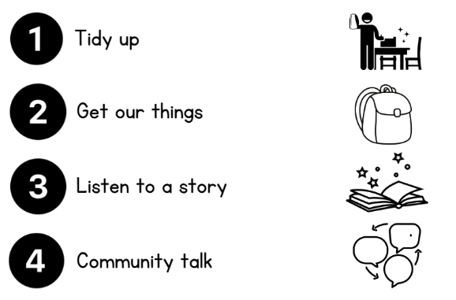
- Explicitly teach the children routines for all common activities using visuals.
- Insist that this routine is followed by every child, every time, defending the high standard so that it becomes a habit.
- Recognise and draw attention to when the expectations are met so children are provided with a constant model of the expectations for a routine.

Core routines and expectations at St Martha’s:

- Taking turns to talk in lessons.
- Waiting until asked to speak (hands up, lolly sticks).
- Listening to each other.
- Silence when the teacher is addressing the class.
- Following instructions the first time they are given.
- Moving quietly and carefully about the classroom and corridors.
- Entering and leaving the room in an orderly and sensible manner.
- Doing our best to complete work in a given time.
- Work and talk quietly (unless the task specifically requires otherwise).
- Handle books and equipment and each others’ work with care and respect.
- Return all books and equipment to their correct place after use.
- Entering and exiting assemblies in silence, single file, and with prayer hands.
- Remaining standing in assembly until class teacher indicates the class should sit.
- Remaining in silent during assembly unless singing or making an invited contribution.

Responses: Recognising and Celebrating Behaviour

'If you consistently reward minimum standards then children will strive for minimum standards. If you reward children for going over and above then there is no limit to their excellent behaviour.' Paul Dix

The school praises children for learning and positive behaviour at every opportunity. We want children to feel proud and grow in confidence as a result of the praise and rewards they get from staff and parents. Staff should strive to ensure that the giving of rewards is balanced, fair and equitable.

Whole School Recognition
- At our weekly Celebration Assembly, one child from each class will be acknowledged with a certificate, and these will be presented by the class teacher. They will be chosen for living out our values in their actions and words, and praised for the positive impact that their efforts have had on learning.
- During our weekly Values Assembly, children and staff are celebrated for living out our school values.

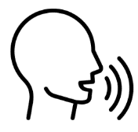
Classroom Recognition

- Acknowledge: All staff should look to acknowledge children for positive behaviour whenever possible as this highlights to all children the positive conduct, which we are looking for. Naming the behaviour (John is standing still and looking straight ahead, ready for assembly! ) or a simple ‘thank you’ are effective. This can be reinforced by informing parents via Class Dojo or verbally at the end of the day.

- House Points: reward points are referred to as House Points. Some teachers choose to record these via a display or whiteboard; others use Class Dojo to award points. House Points are awarded for going above and beyond the expectations we have for all children (meeting of basic expectations should simply be acknowledged). In KS1 House Points may be awarded for meeting classroom expectations to help reinforce the learning of new routines.

- Whole Class Rewards: Teachers may choose to use a whole class reward system such as Team Ticks, a Marble Jar or Stars in the Jar. Ticks/stars/marbles are awarded in recognition of the positive contribution that an individual or group effort makes to learning in their class. Marbles or ticks collected earn a reward for the whole class. Each class will agree the reward with their teacher in advance. Ticks and marbles should not be taken away from the class as this can cause resentment and impacts negatively on relationships in the classroom.
- When a child’s conduct has been exceptional – a role-model for all – a message can be sent via Class Dojo or parents can be informed at the end of day in person.

Responses: Behaviour that Challenges

'Children need people, not punishment. It is time we gave them what they need to succeed, not simply what we feel they deserve. Exclusion and heavy sanctions rarely meet the needs of the child.' Paul Dix

At St Martha’s we believe consequences should be:

 |  | 
Timely  Delivered as soon after the incident took place as possible provided all children involved are well regulated. | Proportional  The consequence is appropriate to the behaviour, the age of the child and the individual children involved. | Educational  The consequences should involve opportunities to reflect, problem solve collaboratively and make plans to ensure the incident does not reoccur.

We use the The Intervention Ladder to manage challenging behaviour. We ensure this is done discreetly and with dignity.

The Intervention Ladder
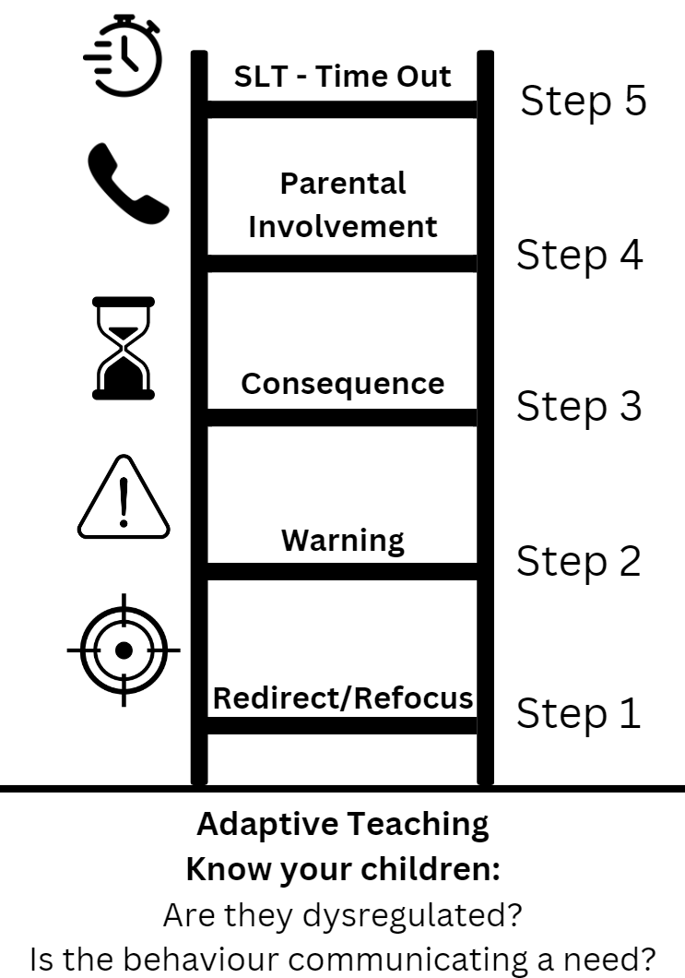
The ladder is a series of interventions used by staff to respond to challenging behaviour. The ladder does not have to be taught explicitly to children but it is important they understand what will happen if they behave in a way that negatively impacts on learning. When a warning is given (Step 2) the teacher will may it clear to the child what the next step will be if they do not get ‘back on track’. This might sound like:

“I can’t allow you to shout out and distract others. If you keep shouting out you are going to have to stay and talk to me about this at break time. You are now going to listen and put your hand up when you have something to share. I know you can do this.”

The ladder can be used multiple times throughout the day. Each session is a fresh start but it is at the teacher’s discretion to move to Step 4 or 5 depending on prior incidents that day (for example, if a child has already had a consequence (Step 3) and behaviour persists, the teacher may skip Step 3 and move to Step 4.

Adaptive Teaching/Know your children

The Ladder should rest on a secure foundation of Adaptive Teaching. We should be meeting the needs of all our children and providing a calm, purposeful environment in which they can learn. We approach behaviour with curiosity. If a child is clearly dysregulated, they are offered the chance to go to the Calm Corner or have an appropriate sensory break.

Step 1 – Redirect and refocus

Children who display low-level disruptive behaviour are given a non-verbal or verbal reminder of expectations. Teachers may:

- Positively praise children who are meeting expectations.
- Remind the child of expectations.
- Use positive cueing (call-and-response, proximal praise) and redirection.
- Eye contact (stern stare, raised eyebrow)
- Name…pause…technique

Step 2 - Verbal/Visual Warning

Children who continue to disrupt may be:

- Given a private verbal reminder of the desired behaviour.
- Told specifically but privately to cease negative behaviour (where appropriate a de-escalation script might be used - Appendix B).
- Individual Behaviour chart referred to (if used as part of a prior Behaviour Plan).
- Reminded of the choices and consequences of continued inappropriate behaviour.
- Set a time limit for finished work/improved behaviour/choices.
- Moved to another seat/end of row in assembly.
- Sat with another adult near to them

Step 3 - Consequences

Teachers may use the following consequences:

- '3 minutes owed'- a reflective time where the child and class teacher privately discuss their actions and how it has impacted on others. This will be at the start of break or lunch The purpose of this is to enable the adult to remind the child of our school values and to encourage positive behaviour in future. The school’s ‘Reflect and Reset…’ form may be used at this stage (Appendix A).
- 'Pay it Back time'- is an appropriate action linked to the incident and value which has not been shown. For example, if a child has not completed class work due to failure to respond to positive strategies, work may be sent home. Another example would be if there has been vandalism in the playground we may ask the child or children involved to help repair the damage.
- Parents may be informed via ClassDojo or at the end of school day as appropriate.

Step 4 - Parental Involvement
- The class teacher will contact the parent via Class Dojo or phone call (it is at the teacher’s discretion whether to send a message or call depending on the circumstances, the child, previous incidents etc.). If necessary, SLT can be contacted to provide temporary cover for the class so that a call can be made if this is deemed to be the most appropriate and effective intervention. The conversation should be used to:

- Make it clear that the behaviour is not acceptable and does not follow the values of the school and our high expectations
- Ascertain if there are any circumstances that we need to be aware of as a school.
- Outline any support we have or are putting in place.
- Make it clear that SLT involvement will be necessary if this behaviour reoccurs.
- This conversation should be recorded on CPOMS.


- Step 5 - SLT Time out

- Classroom staff will phone the office.
- A member of SLT will come and remove the child.
- Work should be provided for the child to complete.
- The amount of time the child is out will depend on age and circumstances.
- Time Out should always be followed up by talking to the child to reflect and reset and to plan for better choices next time using the school’s Reflect and Reset form (Appendix A). Staff may use a restorative script (Appendix B). This can only happen when the child is calm and ready to talk. Therefore, this may be up to 24 hours later. This may be carried out by SLT or classroom staff.
- The incident should be recorded on CPOMS and the Reflect and Reset sheet should be scanned and uploaded.
- If physical intervention is necessary, reasonable and proportionate, staff should use our school approved physical interventions (see Appendix C and/or our Safe Touch Policy).


Responses: Zero Tolerance Behaviour

There are certain types of behaviour for which there is zero tolerance. These include:

- Bullying (verbal, physical, cyber bullying or threatening behaviour online, racist bullying, sexual bullying, homophobic bullying, bullying related to disability)
- Swearing
- Racist abuse (racist taunting and harassment, derogatory racist statements, swearing that can be attributed to racist characteristics, racist bullying, racist graffiti)
- Verbal abuse/threatening behaviour against pupil (threatened violence, aggressive behaviour, swearing, verbal intimidation)
- Verbal abuse/threatening behaviour against adult (threatened violence, aggressive behaviour, swearing, verbal intimidation)
- Physical assault against pupil (fighting, violent behaviour, wounding, obstruction)
- Physical assault against adult (violent behaviour, wounding, obstruction)
- Sexual misconduct (sexual abuse, sexual assault, sexual harassment, lewd behaviour, sexual bullying, sexual graffiti)
- Leaving the school premises without permission
- Vandalism
- Refusal to follow adults’ instructions or deliberately ignoring an adult
- Abuse against sexual orientation and gender identity
- Abuse relating to disability
- Inappropriate use of social media or online technology
- Persistent or general disruptive behaviour

Such behaviour may result in an immediate detention. The class teacher/Assistant Headteacher/ Headteacher will telephone the child’s parent to let them know what the child has done and to warn them that repeated incidences of the behaviour could result in a fixed period exclusion from school.

A second incidence of zero tolerance behaviour will result in the child’s parents being contacted by the Headteacher and the child may be excluded from school for one or two days. All zero tolerance behaviour will be logged on CPOMs.

- Exclusion (for more detailed guidance an information see the school’s Exclusions Policy)
- On very rare occasions it may be necessary to exclude a pupil on a temporary or permanent basis. A decision to do this is not undertaken lightly, and is certainly not imposed without due consultation with all those involved with the pupil, and not without trying every possible alternative first. It is acknowledged that most children and their parents prefer to work towards a positive solution to difficulties and appreciate the opportunities the school can offer in encouraging a pupil to feel able to secure his/her own future within the school environment. A few children may get straight to this stage because of an isolated, very serious incident or because they have not responded at earlier stages and are still choosing not to try to manage their own behaviour. The behaviour is recorded on CPOMs and parents/carers will be notified by the Headteacher either by telephone or face to face at the end of the school day.
Some serious behaviours will result in an immediate exclusion for one or two days.
These include but are not limited to:

- Deliberate aggressive or violent behaviour
- Serious damage to property
- If a child continues to be aggressive/very disruptive and refuses to follow adults’ instructions to stop
- Behaviour as an Additional Need
- Behaviour Plans
This Behaviour Policy supports the majority of children to meet our high expectations. Some children, however, require additional support and intervention. In this case, classroom staff will track behaviour to identify triggers and functions of behaviour. At this stage, reasonable adjustments will be put in place such as: short, planned sensory breaks, adjusting seating plans and the use of the Sensory Room or Calm Corner. If it is clear that further intervention is required, a Positive Behaviour Plan will be put in place by the SENDCO or Behaviour Lead in collaboration with classroom and any other relevant staff. This process often involves: inclusion of the child’s voice, involvement of the parents and parent voice, carefully tailoring of rewards and sanctions to meet their needs. These plans are reviewed periodically with parents and classroom staff.

SEND
The school recognises that children’ behaviour may be impacted by a special educational need or disability (SEND). When incidents of behaviours that challenge arise, we will consider them in relation to a pupil’s SEND, although we recognise that not every incident of behaviour that challenges will be connected to their SEND. Decisions on whether a pupil’s SEND had an impact on an incident of behaviour that challenges will be made on a case-by-case basis.

When dealing with behaviour that challenges from children with SEND, especially where their SEND affects their behaviour, the school will balance their legal duties when making decisions about enforcing the behaviour policy. The legal duties include:
- Taking reasonable steps to avoid any substantial disadvantage to a disabled pupil being caused by the school’s policies or practices (Equality Act 2010)
- Using our best endeavours to meet the needs of children with SEND (Children and Families Act 2014)
- If a pupil has an education, health and care (EHC) plan, the provisions set out in that plan must be secured and the school must cooperate with the local authority and other bodies

When considering a behavioural sanction for a pupil with SEND, the school will take into account:
- Was the pupil unable to understand the rule or instruction?
- Was the pupil unable to act differently at the time as a result of their SEND?
- Is the pupil likely to behave aggressively due to their particular SEND?
If the answer to any of these questions is ‘yes’, it may be unlawful for the school to sanction the pupil for the behaviour. The school will then assess if it is appropriate to use a sanction and if so, whether any reasonable adjustments need to be made to the sanction.
The school’s special educational needs co-ordinator (SENDCO) may evaluate a pupil who exhibits challenging behaviour to determine whether they have any underlying needs that are not currently being met.
Where necessary, support and advice will also be sought from the local authority:
- The Inclusions Team
- Norfolk Steps
- SEND Advisors

Roles and Responsibilities
Lunchtime
At lunchtime, supervision is carried out by the Play Coordinator and the Play Team (Learning Support
Assistants and Midday Supervisory Assistants). They can refer to the Headteacher or the Assistant
Headteachers if necessary. All adults on duty are expected to manage children’ behaviour. Usually this
consists of reminding children of the standard of behaviour expected. They may report back to class teachers briefly at the end of lunchtime.

The Play Team use the following system:

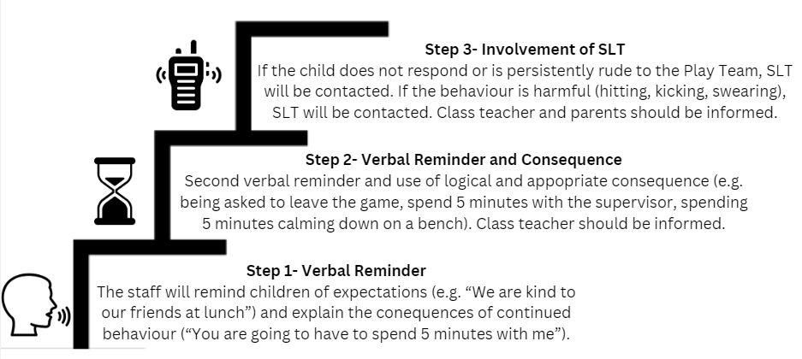

The Play Team must be treated with the respect expected by all adults at St Martha’s Catholic
Primary School. Verbal or physical abuse will not be tolerated.

Extra-Curricular Clubs
At St Martha’s we offer a range of extra-curricular clubs to all children. Clubs are run by school staff. Children attending extra-curricular clubs are expected to listen to and respect the adult that runs the club and follow any rules that may apply to the club. Any pupil who is disruptive impolite or not able to follow the instructions given by the adult in charge, may receive a warning or forfeit their place in the club.

The Role of Leadership

Although the responsibility of ensuring positive behaviour management is shared across the whole staff, the Headteacher, Assistant Headteachers and SENDCo have a responsibility to ‘lead from the front’. The leadership team will assess staff needs and build into the school’s professional development programme opportunities to discuss and learn about behaviour management. Senior staff will ensure that they are highly visible at particular times of the day, to noticeably reinforce good behaviour and swiftly manage any poor conduct by children. Critical times are at the beginning and end of the school day, break times and transitions between lessons/to and from assembly. Senior managers regularly walk around the building, going into classrooms and supporting teachers in their application of this policy.

The Role of Parents

The school strives to work in partnership with parents, so children receive consistent messages about how to behave at home and at school. We endeavour to build a supportive dialogue between the home and the school, regularly informing parents of their child’s successes, as well as informing them immediately if we have any concerns about their child’s welfare or behaviour. Where children require support, staff will endeavour to share and discuss strategies so that parents can better support at home. If a parent has any concerns over the way in which the school has treated their child, they should initially contact the class teacher. If they remain concerned, they should then contact the phase leader and finally the Headteacher if they feel the matter hasn’t been resolved.

Monitoring

The Headteacher monitors the effectiveness of this policy on a regular basis. They also report to the Governing Body on the effectiveness of the policy and, if necessary, make recommendations for further improvements. The class teacher keeps a record of behaviour incidents on CPOMs for those children on behavioural plans and monitors this to ensure children receive the correct support. Records may also be used to inform any referrals that may need to be made, both within school and to external agencies. A record of time-outs and significant incidents that occur at lunchtimes is held on CPOMs. The Headteacher keeps a record of serious incidents, as well as records of bullying and racism, which are reported to Governors. All historic behaviour letters are saved in pupil files and, from September 2019, on CPOMs, together with exclusion forms and letters. It is the responsibility of the governing body to monitor the rate of fixed-term and permanent exclusions, and to ensure that the school policy is administered fairly and consistency.
Appendix A: Restorative Practice Board

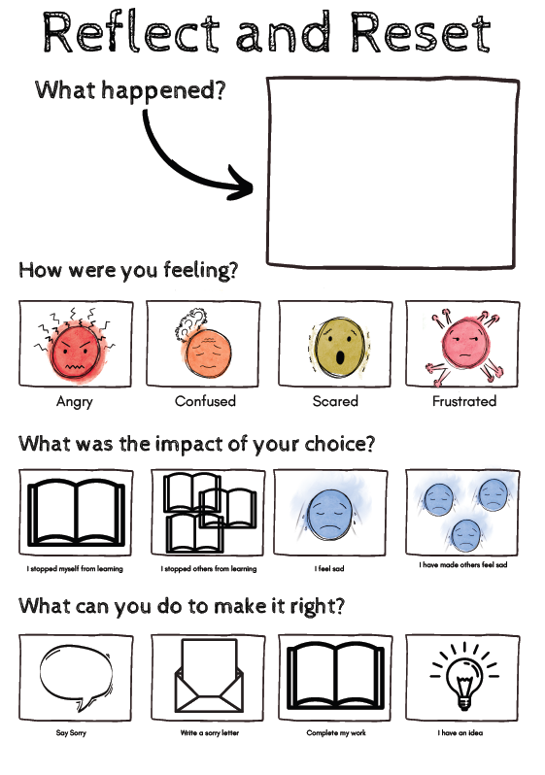

Appendix B: Scripted Responses
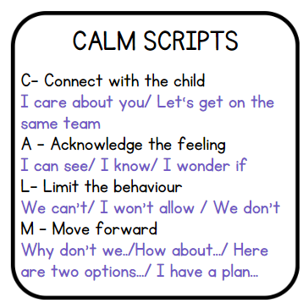
- Descalation Scipts (C.A.L.M. Scripts)

Connect: “I’m here to help.”
Acknowledge: “I can see you’re angry/frustrated/sad. That’s okay.”
Limit: “We can’t hit people/throw things/refuse to do our work.”
Move forward: “We can take 5 minutes in the Calm Corner/go for a quick sensory break/do the next question together.”

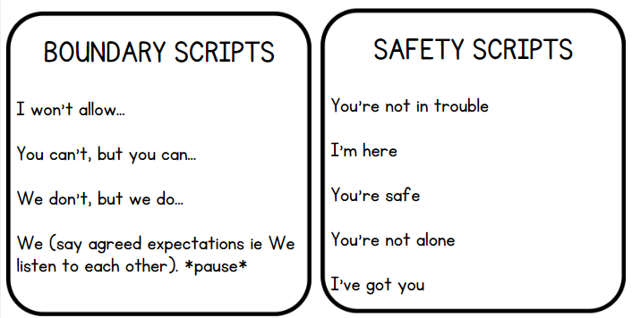

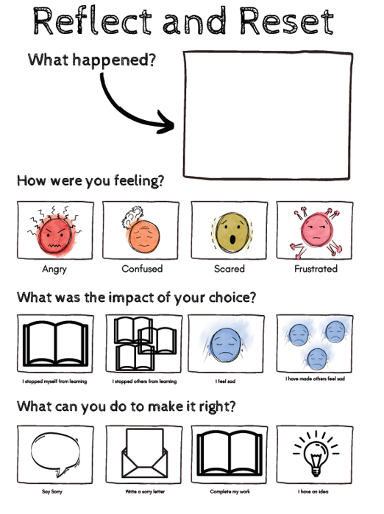
- Restorative Practice Scripts (To be used alongside Reflect and Reset Sheet)

“I’m here to help.”

“What happened?”

“What were you feeling/thinking before this happened?... What were they feeling/thinking?”

“What is the impact of your choice?”

“What can we do to make it right?””

Appendix C:
Norfolk STEPS Approved Physical Interventions

Non-restrictive Physical Interventions (Step On)

Hand Shapes
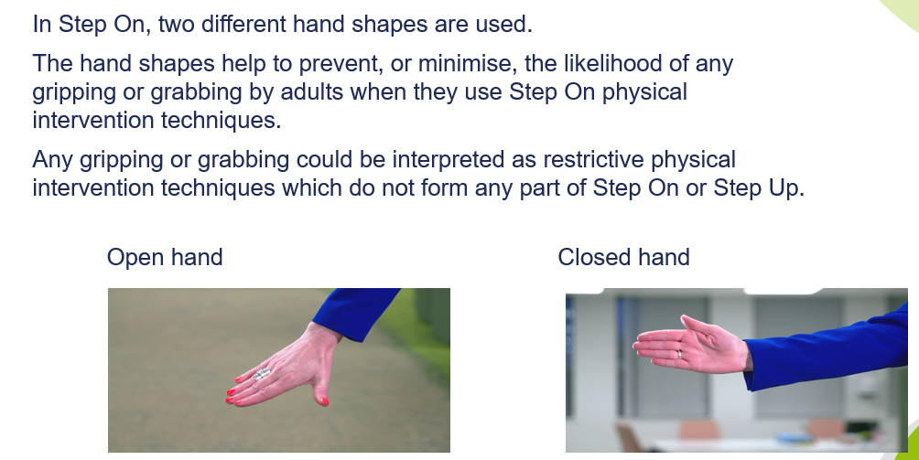
Open Hand
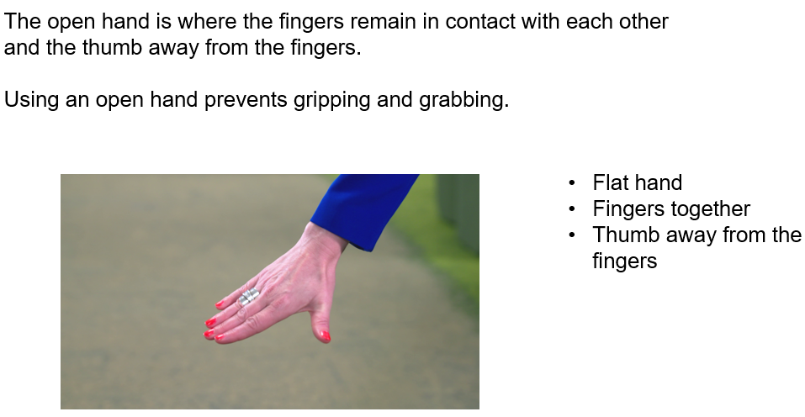

Closed Hand
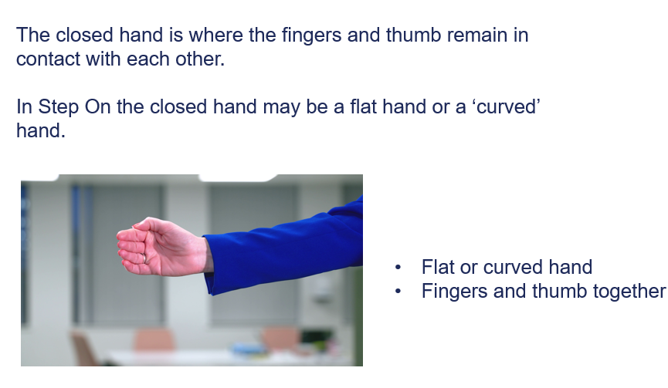
Arm Hug (closed hand)
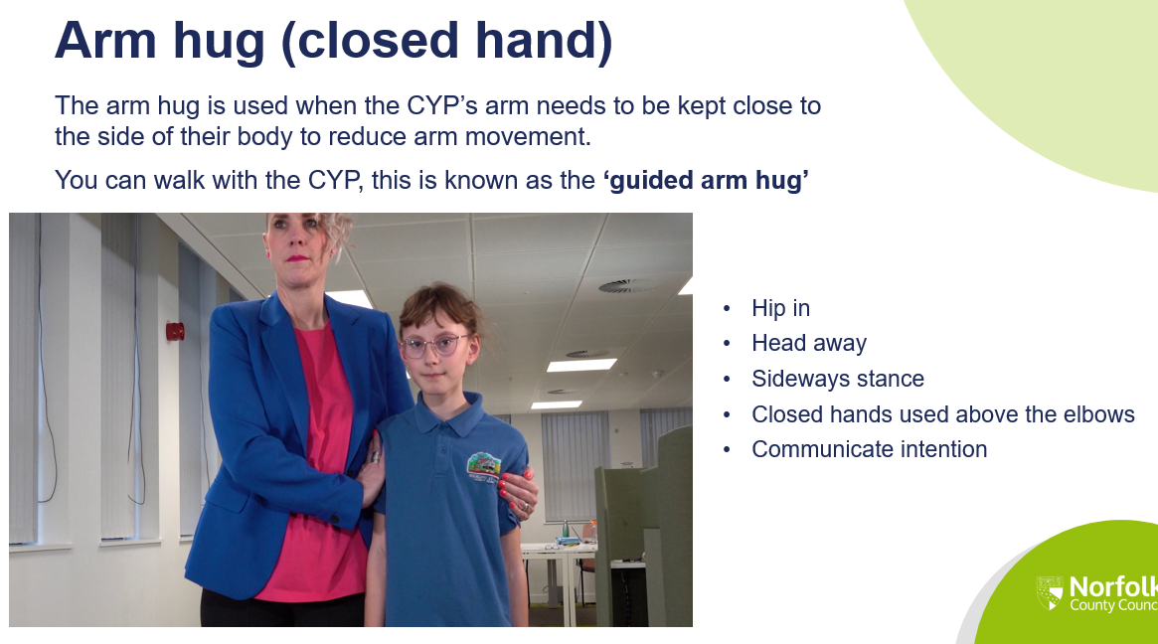

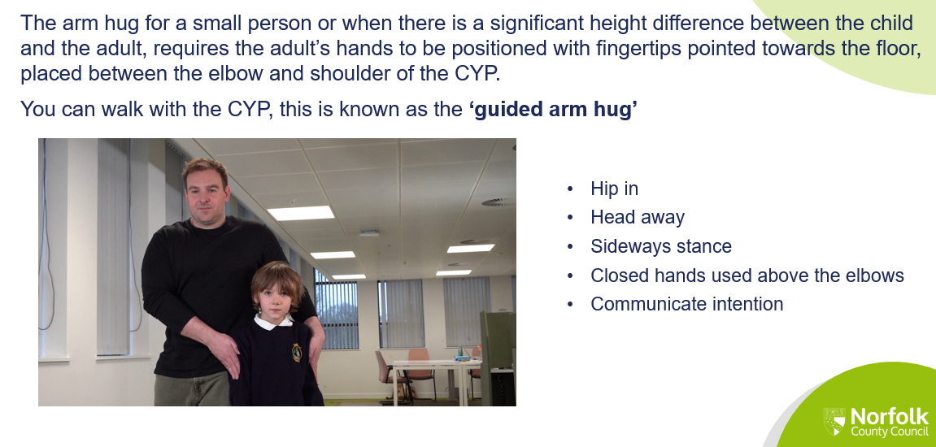
Open Hand to Stabilise and Turn
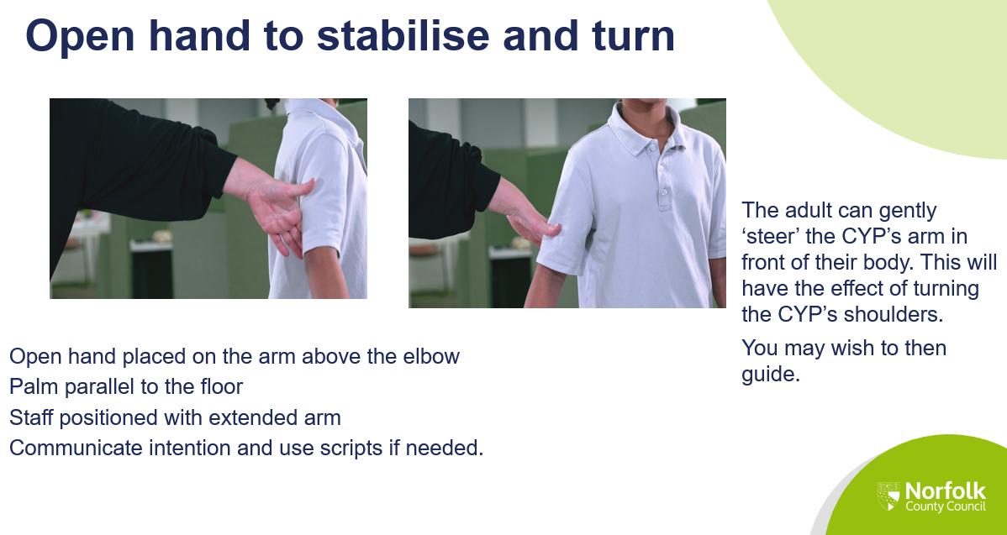

Restrictive Physical Interventions (Step Up)

Only to be used by those that are Step Up trained
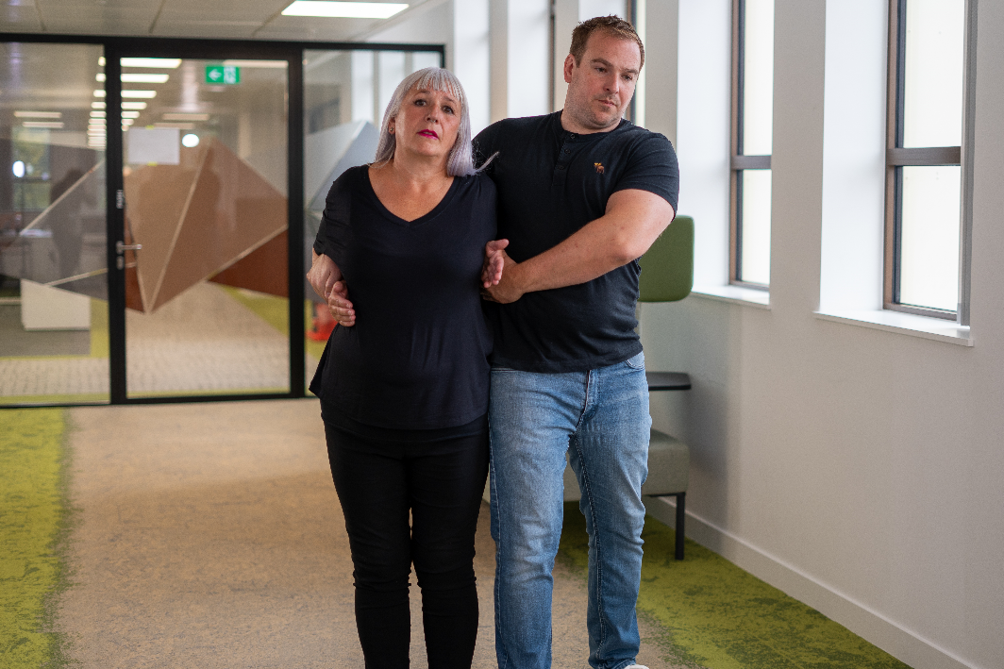

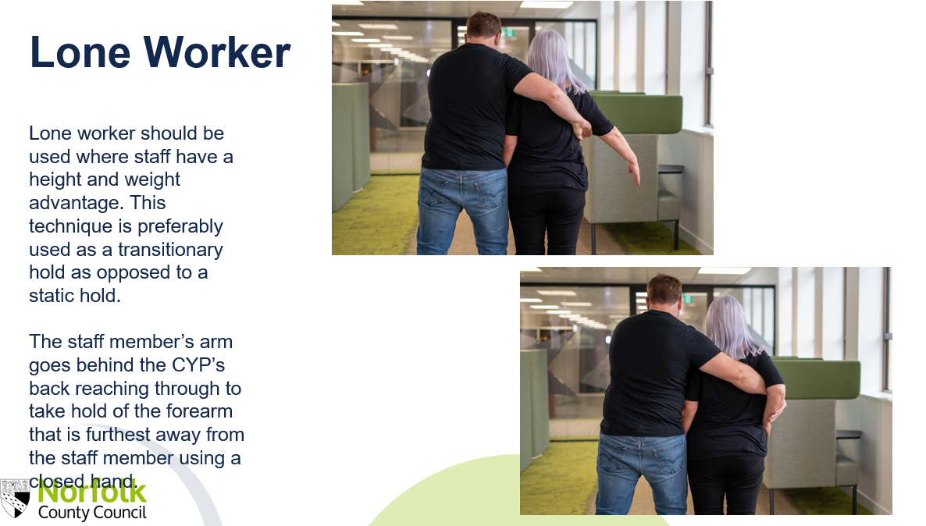

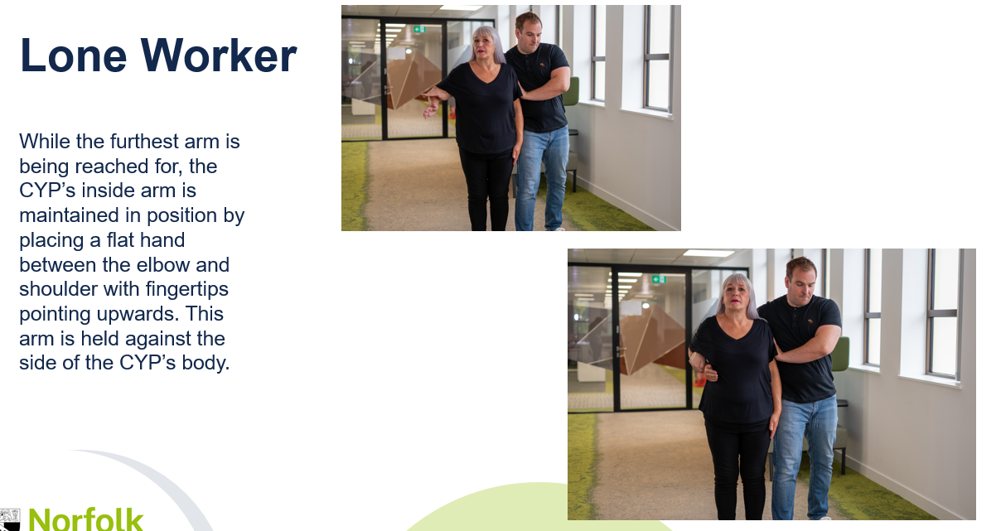
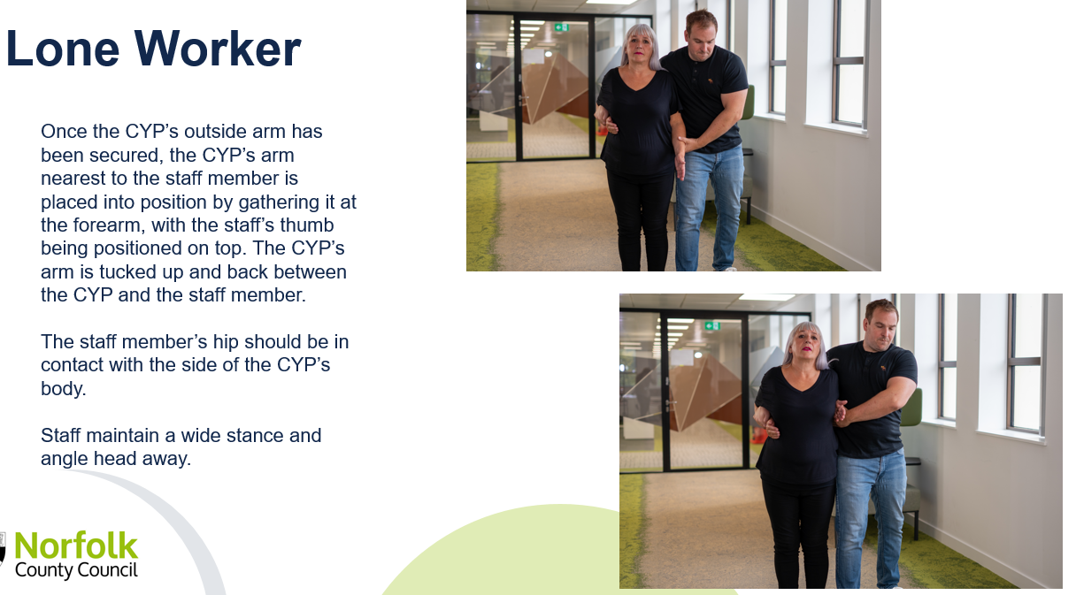

Appendix D: Further Reading

This Behaviour Policy draws upon the latest educational research. The following were referred to in the writing of this policy and are recommended further reading:

The EEF, Improving Behaviour in Schools Guide, 2019

https://d2tic4wvo1iusb.cloudfront.net/production/eef-guidance-reports/behaviour/EEF_Improving_behaviour_in_schools_Report.pdf?v=1728290756

Tom Bennett, Creating a Culture, 2017

https://assets.publishing.service.gov.uk/media/5a7506e4ed915d3c7d529cec/Tom_Bennett_Independent_Review_of_Behaviour_in_Schools.pdf

Charlie Taylor, Getting the simple things right: Charlie Taylor’s behaviour checklists

https://www.wigan.gov.uk/Docs/PDF/Resident/Education/Educational-Support/TESS/Charlie-Taylor-checklist.pdf
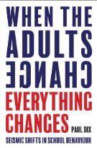
Paul Dix, When the Adult Changes, Everything Changes, 2017

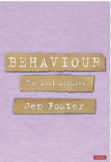
Jen Foster, Behaviour: The Lost Modules, 2023

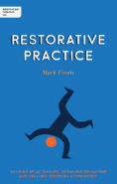
Mark Finnis, Restorative Pracice, 2021

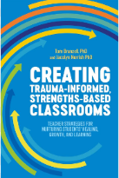
Tom Brunzell and Jacolyn Norrish, Creating Trauma-Informed, Strengths-Based Classrooms, 2021

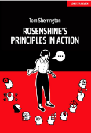
Tom Sherrington, Rosenshine’s Principles in Action, 2019

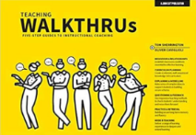
Oliver Caviglioli and Tom Sherrington, Teaching WalkThrus, 2020

