Our vision is to create a community based on Catholic faith and values where every child is empowered to be the best he or she can be, nurtured by outstanding teachers, staff and governors

Home Learning Policy 2022

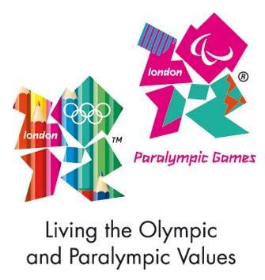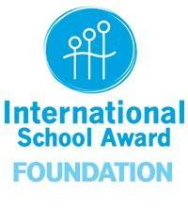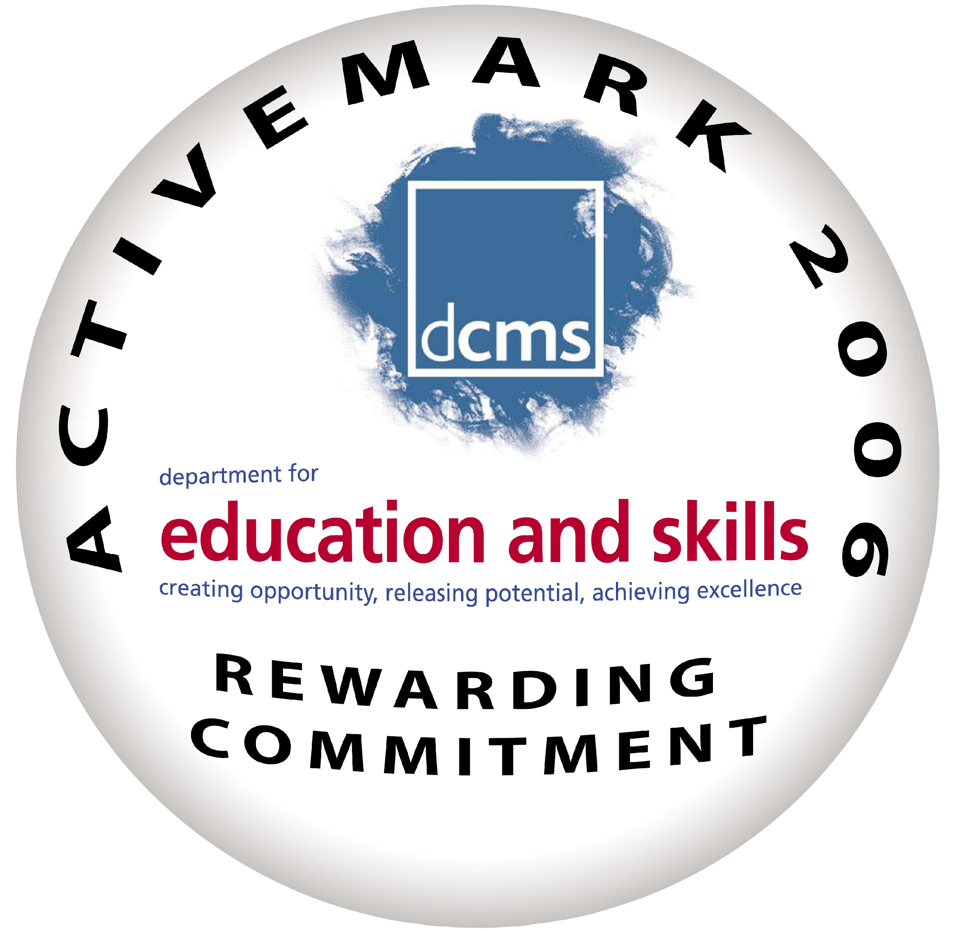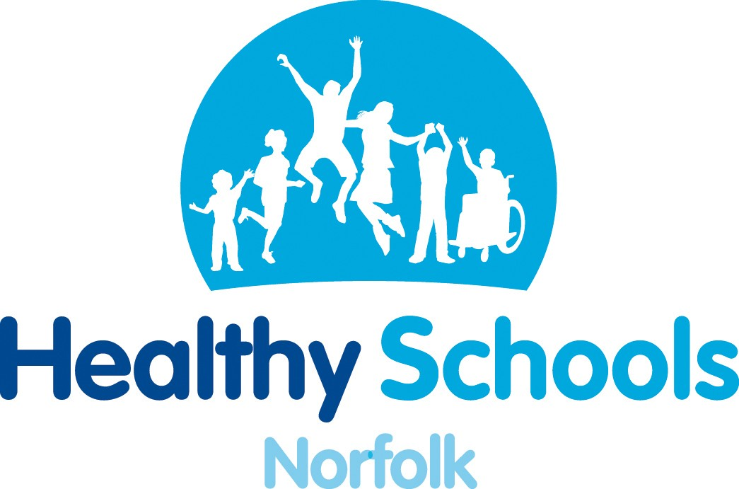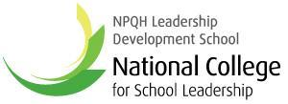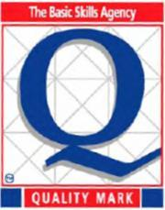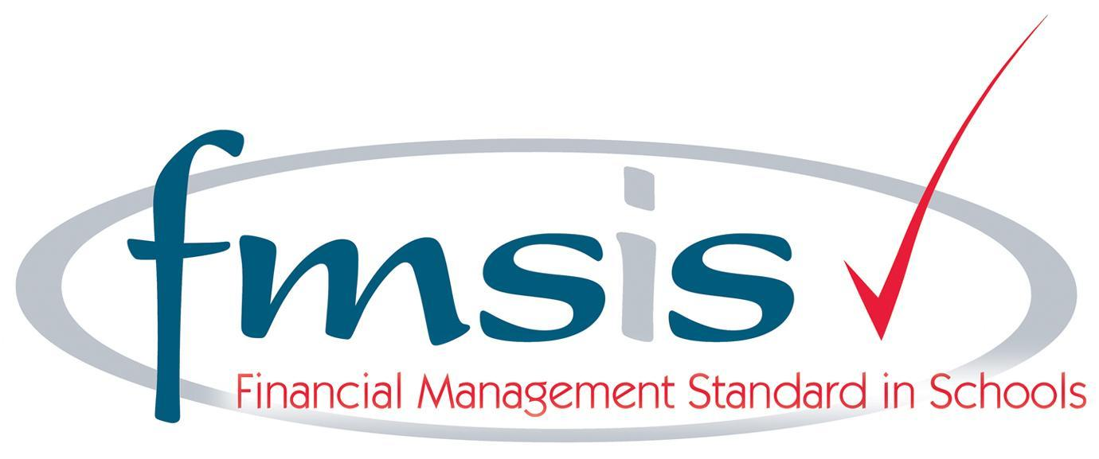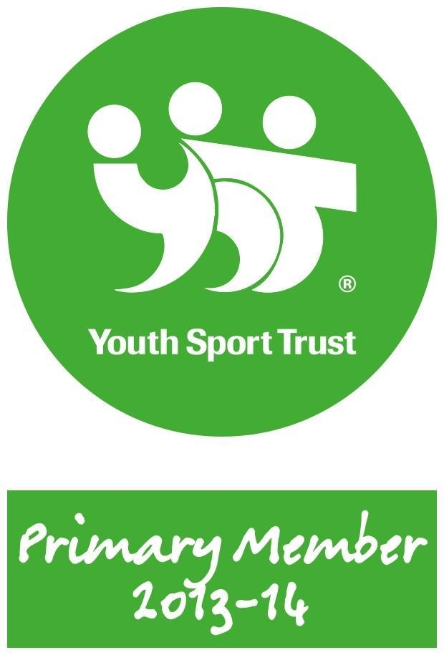

St Martha’s Catholic Primary School
Home Learning Policy

Aims

- It is an expectation that all children will carry on learning at home and that all teachers set home learning tasks;
- The purpose of home learning is to consolidate and extend the learning of our pupils;
- Learning at home is highly valued by teaching staff. Children will receive regular rewards and feedback on their home learning.

Methodology

Specific home learning tasks will vary according to the age and needs of each child.

Pupils will be set home learning within the following framework:

In EYFS children will receive:

- A weekly guided reading book with a related comprehension sheet once a range of sounds have been taught.This reading should be recorded by an adult in the child’s reading record.
- Fortnightly ‘tricky/ high frequency words’,
- A handwriting sheet linked to the phonemes taught,
- Home learning is also carried out through the regular contribution of children’s learning by parents in the children’s Learning Journey.
- A ‘Next Step Foot’ which is differentiated to meet the developing needs of each individual child. This will change and be sent home as the previous target is met.
In Year 1 children will receive:

- A weekly guided reading book with a related comprehension sheet.This reading should be recorded by an adult in the child’s reading record.
- 10 spellings to practise (reviewing key sounds + tricky words from that week),
- A Home Learning Menu* at the beginning of each half term.
In Year 2 children will receive:

- A weekly guided reading book with a related comprehension sheet.This reading should be recorded by an adult in the child’s reading record.
- 10 spellings to practise (reviewing key sounds + tricky words from that week),
- A weekly times tables sheet,
- A Home Learning Menu* at the beginning of each half term
In Year 3 children will receive:

- A weekly guided reading book with a related comprehension sheet (until children are no longer reading scheme books),
- After this children will have access to the library at least once a week to choose a book to read daily at home. This reading should be recorded by an adult in the child’s reading record.
- 10 spellings to practise (following the Spelling Shed scheme),
- A weekly times tables sheet,
- A Home Learning Menu* at the beginning of each half term.
In Year 4 children will receive:

- Children will have access to the library at least once a week to choose a book to read daily at home. This reading should be recorded by an adult in the child’s reading record.
- 10 spellings to practise weekly (following the Spelling Shed scheme),
- A weekly times tables sheet,
- A Home Learning Menu* at the beginning of each half term.
In Year 5 children will receive:

- Children will have access to the library at least once a week to choose a book to read daily at home. This reading should be recorded by the child in their reading record,
- 10 spellings to practise (following the Spelling Shed scheme),
- A weekly times tables sheet,
- Short weekly tasks in reading, maths and grammar (for example, ‘fluent in 5’).
- A Home Learning Menu* at the beginning of each half term.
In Year 6 children will receive:
- Children will have access to the library at least once a week to choose a book to read daily at home. This reading should be recorded by the child in their homework diary,
- 10 spellings to practise (following the Spelling Shed scheme),
- Extended weekly maths, reading and grammar tasks,
- An optional Home Learning Menu* at the beginning of each half term to cover the wider curriculum.
* Home learning menus should include a range of tasks which the children must choose from. They are based upon the children’s learning in school during the term. The menus combine flexibility and enjoyment with high expectations. The tasks may be set to specifically target the maths and English taught.

Other Considerations

- Children from Year 1 to Year 6 should be given an exercise book or folder in which to complete their home learning with the Home Learning Menu stuck in. Children should be given access to any materials they might need to complete their home learning (e.g. stationery).
- In Key Stage 2, children’s library book choices should be guided to ensure they are of the appropriate difficulty.
- During half term holidays, children will be asked to read. No home learning should be set, except from Year 6 in the spring term to prepare for their end of Key Stage 2 assessments.
- Adaptations should be made for children on the SEND register.

Parental Involvement

We anticipate that parents will actively support their child’s out of school learning. The success of any home learning is to a great extent dependent on parental support. This interest and support will inform parents about the type of tasks their children are undertaking. Parental involvement is highly valued and encouraged.

Reviewed by staff: October 2022

