

**Safe Touch Policy**

**2025 - 2026**

**‘Be the best you can be’**

**Field Lane, King’s Lynn, Norfolk, PE30 4AY**

Our vision is to create a community based on Catholic faith and values where every child is empowered to be the best he or she can be, nurtured by outstanding teachers, staff and governors.

**SAFEGUARDING – SAFE TOUCH POLICY**

**STATEMENT OF INTENT**

At St Martha’s Catholic Primary School, we understand that appropriate relationships between staff and pupils are

paramount to promoting the safeguarding of children at our school.

We believe that the use of touch is a vital aspect of our nurturing role and that adult physical contact is not only inevitable but desirable in some cases.

Touch not only promotes a child’s social and emotional development but is also a highly effective and powerful method of non-verbal communication, it is key to the development of healthy relationships and a method of stress relief. It can be used to:

-Show acceptance

-Provide reassurance

-Calm and provide comfort

-Emphasise the spoken word

-Provide sensory stimulation

-Engage in personal care routines

-Deliver various therapy programmes

-Offer an alternative to spoken communication

-Remove a child from danger or keep a child safe

When appropriate touch is discouraged, children may not learn to distinguish between appropriate and inappropriate touch. They may miss out on a whole range of valuable touch experiences – friendly, nurturing, reassuring, comforting and healing. We should be instilling a sense of what appropriate touch is.

Members of staff in a caring school recognise physical contact as an important part of child development and guidance. They understand that physical contact may be communication and they recognise the importance and significance of non-verbal communication and respond appropriately. This should always be done in a developmentally and age appropriate way, the child’s wishes will always be respected by the member of staff dealing with the situation. Touch in the form of hugs must be instigated by a child, not an adult.

Therapeutic touch is used in situations where children are distressed. In these situations, research has shown that it would be unkind or increase the child’s distress if touch was not employed. When children are very distressed they often ignore information provided by their senses for example they may no longer see or no longer hear. When a child is distressed, touch can be the only means of maintaining a connection with the child.

This Safe Touch Policy has been created with the aim of ensuring that all members of staff are aware of their responsibilities in terms of appropriate and inappropriate touch when involving pupils.

All children are entitled to receive an education in an environment where they feel safe, secure and respected. The school dedicates itself to ensuring that no pupils feel threatened or disrespected, in terms of physical contact between themselves or a member of staff.

**LEGAL FRAMEWORK**

This policy has due regard to the following legislation, including, but not limited to:

-The Children Act 1989

-Equality Act 2010

This policy will also have due regard to the following guidance:

-Use of reasonable force and other restrictive interventions guidance 2025

-DfE ‘Use of reasonable force in schools’ 2013

-DfE ‘Working together to safeguard children’ 2015

The school will implement this policy in conjunction with our Safeguarding Policy, Health and Safety Policy, Behaviour Policy and Equality Policy.

**Terminology**

For clarity, this guidance will use the following definitions:

**Reasonable force:** Physical contact by a member of staff on a pupil to control or restrain their actions/movements. Reasonable means using no more force than is necessary for the least amount of time, the application of which will depend on the circumstances. Any use of reasonable force is an example of a restrictive intervention and may or may not involve the use of restraint.

**Restrictive interventions**: Any planned or reactive action which limits a pupil’s movement, liberty or freedom to act independently. Restrictive interventions may or may not involve the use of reasonable force.

**Restraint:** A form of restrictive intervention involving direct physical contact and force where the intention is to prevent, restrict, or subdue movement of the body, or part of the body, of a pupil.

As noted within the definitions, these terms are not necessarily mutually exclusive categories. For example, depending on the circumstances, if two members of staff briefly physically pull apart two pupils who are fighting, all three definitions could be relevant.

The decision on whether it is reasonable to use force and/or other restrictive interventions, as defined in the terminology section above, depends on the individual circumstances of each situation. In assessing whether force and/or other restrictive interventions are reasonable in a situation, the member of staff should use their professional judgement.

***Factors staff might want to consider include:***

* **Is it necessary?**

Staff should consider whether there are reasonable alternative ways to manage a situation and achieve the desired outcome. Staff should assess whether the use of reasonable force and/or other restrictive interventions is likely to successfully reduce the relevant risks, or whether its use would escalate the situation further or cause more harm than the consequences of the behaviour that it intends to address. Where possible, staff should communicate with other staff members to understand any broader risks in the environment.

* **Is it proportionate?**

Staff should use the least amount of force or least restrictive intervention necessary for the least amount of time required to reduce the relevant risks. Staff should consider the personal circumstances of the pupil such as medical conditions, special educational needs or other vulnerabilities, their characteristics such as age and size, and must consider relevant equality implications under the Equality Act 2010.

* **Have you considered the pupil’s welfare?**

Staff should consider the impact on the pupil’s overall welfare, balanced against any actions taken. For example, pupils who have experienced an adverse life event, with diagnosed or undiagnosed medical conditions or sensory impairments, past trauma or neglect, communication difficulties, or other needs, may find the use of reasonable force and other restrictive interventions particularly distressing. Staff should seek to maintain respect for a pupil’s dignity. This may include, where possible, considering the location and environment where any intervention is used, such as in front of their peers. Where possible, staff should clearly and calmly communicate to the pupil what is happening, why, and explain what the pupil needs to do. For pupils with difficulties with speech, language and communication, or with English as an additional language, verbal and/or non-verbal strategies should be used to ensure the pupil understands what is happening and has adequate time to process information and respond. Staff should seek to understand how the pupil is feeling and use this information to determine whether the use of reasonable force and/or other restrictive intervention should be, or continue to be, applied, reduced or stopped.

This list of factors is not definitive, and consideration must be given to all other relevant factors. Training on the use of reasonable force and other restrictive interventions should support staff in assessing when the need to use force and/or other restrictive interventions is reasonable, which may require a quick decision.

**ROLES AND RESPONSIBILITIES**

All members of staff at our school have a duty of care towards pupils, and must be aware of the boundaries involving physical contact.

The Designated Safeguarding Lead (DSL) is responsible for conducting annual safeguarding training for all members of staff and ensuring that they are aware of their responsibilities, in line with the school’s Safeguarding Policy.

The Headteacher is responsible for ensuring that all staff engage in safe touch with pupils.

All members of staff are responsible for ensuring that no pupil feels threatened or unsafe at our school as a result of inappropriate touch.

All members of staff have a responsibility to report any instances of inappropriate touch to the Headteacher and DSL via Staff Safe.

The Headteacher is responsible for communicating with parents/carers and ensuring that they are aware of this policy.

The school has a responsibility for ensuring that they create and promote a culture in which pupils’ wishes and feelings are respected.

Following a significant incident in which reasonable force and/or other restrictive interventions are used, schools should hold a follow-up conversation(s) to facilitate reflection, learning and to support pupil and staff wellbeing. This conversation should be framed as part of the overall debriefing process and look to understand what happened during the incident and why, based on separate reflections from both the staff and pupils involved; as well as to repairing and rebuilding relationships through dialogue. This process should ideally be facilitated by a staff member who was not involved in the incident and may also benefit from the presence of an additional person to ensure impartiality and support. By engaging in this process, schools can foster a culture of continuous improvement and consider how things might be improved in the future. Where a restrictive hold or reasonable fore has been used this must always be clearly documented on the CPOMs system.

**­­**

**WHAT IS SAFE TOUCH?**

For the purpose of this policy, “safe touch” is defined as physical contact that, if otherwise avoided, would be inhumane, unkind and potentially emotionally or physically damaging for the pupil.

Safe touch should never be invasive, humiliating or flirtatious.

The school understands that the following examples are instances of safe touch which may occur between staff and pupils:

-Comforting an upset or distressed pupil,

-Congratulating or praising a pupil,

-Holding the hand of a pupil to guide them, such as when crossing a road or walking to assembly,

-Giving first aid to a pupil, or supporting with Intimate Care (where a plan is in place),

-Demonstrating exercises or techniques during PE lessons, administering medicine, or when using musical instruments.

**TYPES OF SAFE TOUCH**

The school understands that certain types of physical contact between staff and pupils are inappropriate, such as front on hugging, straddled lap-sitting, or kissing.

When demonstrating how to use sporting equipment or sports skills, staff may need to touch children to support and guide them, for example in gymnastics, hockey, rugby and football.

When learning climbing skills staff may need to use a guiding hand to support younger children.

When younger children are using the climbing equipment staff may need to support them getting up and down-this, where possible, must be done in sight of others. Staff must lift from under the armpits and place the child down gently.

When staff are alone with a child, another adult will be made aware, where possible. The room that they are in must always have a door with a window.

**The school places the following restrictions on hugging:**

At our school we encourage staff using touch for reward or comfort to use the ‘school-hug’, rather than an embrace.

The school-hug is a sideways hug whereby the member of staff places their hands on the pupil’s shoulders.

This type of hug prevents the pupil from turning themselves towards the member of staff and thus engaging in a ‘front’ embrace.

A child should instigate the hug, this should not be done by the adult.

**The school places the following restrictions on holding hands:**

At our school we understand that there are times when a member of staff will need to hold a pupil’s hand, either to guide them or to prevent them from being physically harmed.

Within our Reception and Year 1 classes we will hold a pupil's hand when giving guidance, reassurance or to comfort them. This may also be appropriate for some children within Year 2 and KS2.

We encourage the use of the ‘school hand-hold’. This is done by the adult holding their arm out, and the child is encouraged to either hold the hand or arm of the adult or wrap their hand around the adult’s lower arm.

Children should not be dragged or led against their will. It is a guided hand hold and is in no way restrictive.

**The school places the following restrictions on lap-sitting:**

The school recognises that at times a Reception or Year 1 child may initiate a lap-sitting position on a familiar adult for comfort, in this instance the child’s legs must hang off the right or left side, this type of contact is only made with the consent of the child. The child’s legs should not be in an open position with their body facing the adults.

The school understands that pupils are not always aware of the boundaries between staff and pupils and thus may try to engage in physical contact such as lap-sitting or inappropriate hand-holding and hugging. Should a pupil try to engage in any inappropriate physical contact, the member of staff must encourage them to engage in the school approved ways of hugging, hand holding, touching and lap sitting.

If a member of staff attempts to use one of the safe methods of touch and a pupil is unhappy with this, the member of staff will retract immediately in order to respect the pupil’s wishes.

**REASONABLE FORCE**

The school understands that there are times when members of staff must provide physical intervention whereby a child presents danger to themselves or others. Where a child presents a danger to themselves or to others it will at times be necessary for trained staff to use a means of physical intervention, this will always be in line with the training.

All staff have the legal power to use reasonable force. In these instances, staff must always explain the reasons for their actions to the pupil and why it was necessary.

Reasonable force may be required in order to move or restrain a pupil, such as needing to guide a pupil to safety, this should only be used in extreme circumstances, such as when there is no other way a child or children can be kept safe.

At all times, members of staff must ensure they use reasonable force in such a way as to avoid any injury.

**We follow the Norfolk Steps approach:**

**Norfolk STEPS Approved Physical Interventions**

***Non-restrictive Physical Interventions (Step On)***

**Hand Shapes**

***Open Hand:***

The open hand is where the fingers remain in contact with each other and the thumb is away from the fingers.

Using an open hand prevents gripping and grabbing. 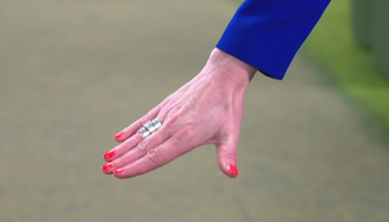

-flat hand

-fingers together

-thumb away from the fingers

***Closed Hand:***

The closed hand is where the fingers and thumb remain in contact with each other. In Step On the closed hand may be a flat hand or a curved hand.

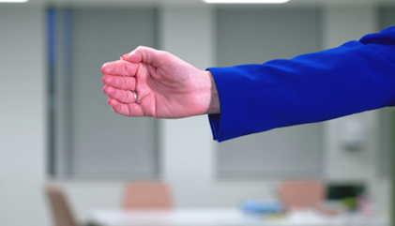

-flat or curved hand

-fingers and thumb together

***Arm Hug (closed hand):***

The arm hug is used when the child’s arm needs to be kept close to the side of their body to reduce arm movement.

You can walk with the child, this is known as the **‘guided arm hug’**.

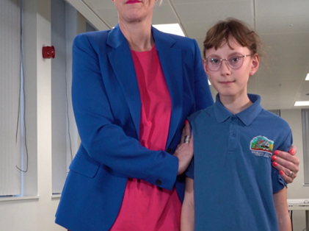

-hip in

-head away

-sideways stance

-closed hands used above the elbows

-communicate intention

The arm hug for a small person or where there is a significant height difference between the child and the adult, requires the adult’s hands to be positioned with fingertips pointed towards the floor, placed between the elbow and the shoulder of the child. You can walk with the child, this is known as the ‘**guided arm hug’**

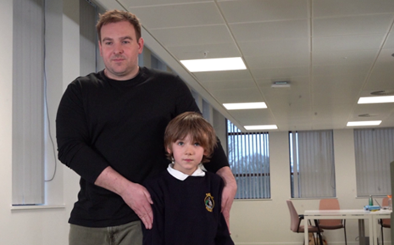

***Open hand to stabilise and turn:***

The adult can gently ‘steer’ the child’s arm in front of their body. This will have the effect of turning the child’s shoulders, you may wish to guide them.

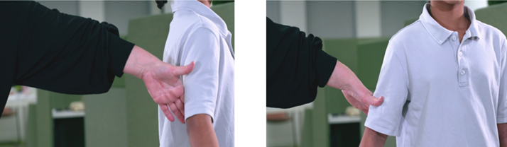

­-open hand placed on the arm above the elbow

-palm parallel to the floor

-staff positioned with extended arm

-communicate intention and use scripts if needed

**Restrictive Physical Interventions (Step Up)**

**(only to be used by those that are Step Up trained)**

***Lone Worker:***

Lone worker should be used where staff have a height and weight advantage. This technique is preferably used as a transitionary hold as opposed to a static hold. The staff member’s arm goes behind the child’s back reaching through to take hold of the forearm that is furthest away from the staff member using a closed hand.

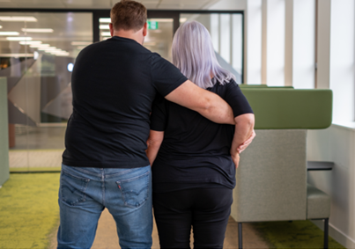

While the furthest arm is being reached for, the child’s inside arm is maintained in position by placing a flat hand between the elbow and shoulder with fingertips pointing upwards. This arm is held against the child’s body.

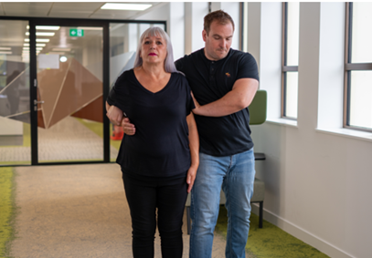

Once the child’s outside arm has been secured, the child’s arm nearest to the staff member is placed into position on top. The child’s arm is tucked up and back between the child and the staff member.

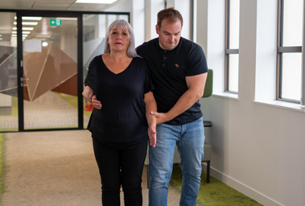The staff member’s hip should be in contact with the side of the child’s body. Staff maintain a wide stance and angle head away.

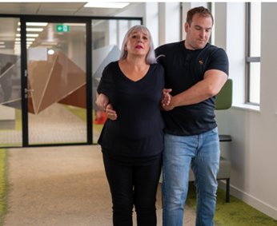

**The school is able to use reasonable force in situations when:**

-Members of staff must prevent a pupil from leaving a classroom only when doing so would lead to a risk of their safety. The school is a safe site and children can be left to move around the school if this is required, rather than being restrained.

-A pupil is attacking a member of staff or another pupil.

-A pupil is at serious risk of harming themselves and a member of staff must intervene to prevent this.

**REPORTING AND RECORDING**

Staff do not need to record incidents where every day physical intervention is used (holding a child’s hand, giving a side hug to comfort).

If a Step On intervention has been used to support a child who is dysregulated this could be recorded on CPOMS when documenting the incident. The Behaviour category should be selected along with the following sub-category: Non-restrictive intervention - (Step on). If a child is on a Behaviour Plan and a particular non-restrictive physical intervention is often used, this should be recorded on their behaviour plan.

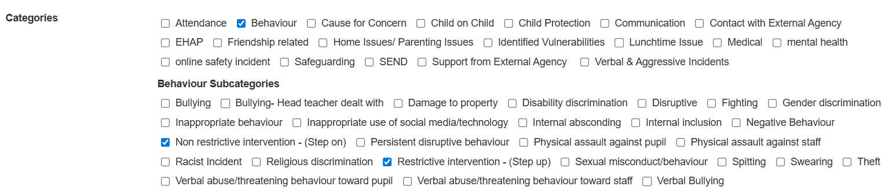All restrictive (Step Up) interventions must be recorded on CPOMS under Behaviour - Restrictive intervention - (Step up).

If a non-approved restrictive intervention is used (for example, a hand-hold becomes non-compliant or an error is made in the use of a restrictive hold), this must be recorded. The person who used force should record the incident on CPOMS. If you observe another staff member use a non-approved holds, it is important that you raise this with the staff member, if possible, and guide them to use an approved intervention or step away. If you have any concerns about a staff member’s use of physical intervention, this should be recorded as a note on Staff Safe or you should talk to a member of SLT.

**TRAINING OF STAFF**

The Headteacher, DSL or Step On Lead Teachers will conduct safeguarding training for all members of staff in relation to safe touch.

All staff will be regularly reminded of the methods of safe touch employed by our school, and will communicate this to the pupils they are in contact with.

All staff who work directly with children have receive Step On training. This is training is updated every two years.

**MONITORING THE IMPLEMENTATION AND EFFECTIVENESS OF THE POLICY**

This policy is reviewed on an annual basis by the Headteacher and DSL, who will make any necessary changes and communicate this to all members of staff.